Acupuncture
What is acupuncture?
Acupuncture is the practice of penetrating the skin with thin, solid, metallic needles which are then activated through gentle and specific movements of the practitioner's hands or with electrical stimulation.
Acupuncture is part of the ancient practice of Traditional Chinese medicine. Traditional Chinese medicine practitioners believe the human body has more than 2,000 acupuncture points connected by pathways or meridians. These pathways create an energy flow (Qi, pronounced "chee") through the body that is responsible for overall health. Disruption of the energy flow can cause disease. By applying acupuncture to certain points, it is thought to improve the flow of Qi, thereby improving health.
What does acupuncture feel like?
Acupuncture is done using hair-thin needles. Most people report feeling minimal pain as the needle is inserted. The needle is inserted to a point that produces a sensation of pressure or ache. Needles may be heated during the treatment or mild electric current may be applied to them. Some people report acupuncture makes them feel energized. Others say they feel relaxed.
Improper placement of the needle can cause pain during treatment. Needles must be sterilized to prevent infection. That is why it is important to seek treatment from a qualified acupuncture practitioner. The FDA regulates acupuncture needles just as it does other medical devices under good manufacturing practices and single-use standards of sterility.
How does acupuncture affect the body?
Acupuncture points are believed to stimulate the central nervous system. This, in turn, releases chemicals into the muscles, spinal cord, and brain. These biochemical changes may stimulate the body's natural healing abilities and promote physical and emotional well-being.
Considerations when choosing acupuncture
It is important to take precautions when deciding about acupuncture.
Discuss acupuncture with your doctor first. Acupuncture is not for everyone. Discuss all the treatments and medicines (dietary supplements, prescription and over-the-counter) you are taking. If you have a pacemaker, are at risk for infection, have chronic skin problems, are pregnant, or have breast or other implants, be sure to tell your doctor. Acupuncture may be risky to your health if you fail to mention these matters.
Do not rely on a diagnosis of disease by an acupuncture practitioner. If you have received a diagnosis from a doctor, you may wish to ask him or her whether acupuncture might help.
Choose a licensed acupuncture practitioner. Your own doctor may be a good resource for referrals to a licensed or certified practitioner. Friends and family members may also be good sources of referrals. You do not have to be a doctor to practice acupuncture or to become a certified acupuncturist. About 30 states have established training standards for certification in acupuncture, although not all states require acupuncturists to get a license to practice. Although not all certified acupuncturists are doctors, the American Academy of Medical Acupuncture can provide a referral list of doctors who practice acupuncture.
Consider costs and insurance coverage. Before starting treatment, ask the acupuncturist about the number of treatments needed and how much the treatments will cost. Some insurers cover the cost of acupuncture while others do not. It is important to know before you start treatment whether acupuncture is covered by your insurance.
What is Moxibustion？
Moxibustion, also called moxa treatment, traditional medical practice that originated in China and thence spread to Japan and other Asian countries. It is performed by burning small cones of dried leaves on certain designated points of the body, generally the same points as those used in acupuncture.
The term moxibustion derives from the name of the wormwood plant most frequently used, Artemisia moxa, or (Japanese) A. mogusa. Acupuncture and moxibustion are sometimes used in combination for the treatment of disease and for anesthesia.
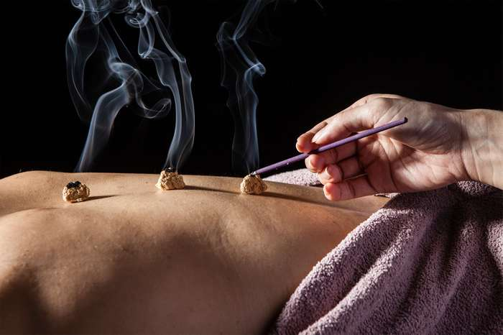

In moxibustion, or moxa treatment, small cones of an herb (typically Artemisia moxa) are burned on top of needles placed in designated points of the body, generally the same points as those used in acupuncture.

Uses
According to alternative medicine practitioners, the heat generated during moxibustion helps increase the flow of vital energy (also known as "qi" ) throughout the body via certain pathways (known as "meridians"). In traditional Chinese medicine, stimulating the flow of chi is considered essential to achieving health and wellness. In fact, physical and mental health problems are thought to develop (in part) as a result of blockages in the flow of chi.
Alternative medicine proponents claim that moxibustion can help treat the following health problems:
- Arthritis
- Back pain
- Headaches
- Migraines
- Muscle stiffness
- Menstrual cramps
- Digestive problems
- Ulcers
- Cancer
- Infertility
- Tendonitis
What Moxibustion Involves ?
There are two main types of moxibustion: direct and indirect. The technique most commonly used today, indirect moxibustion, often involves burning moxa (a substance created from dried leaves of the herbs mugwort or wormwood) on top of the acupuncture needle. In some cases, however, practitioners may set the burning moxa over a layer of ginger, garlic, or salt placed on the patient's skin. Other techniques include applying heat to acupuncture points from an electrical source, as well as holding the burning moxa above the skin for several minutes.
In direct moxibustion, the burning moxa is placed directly on the skin. Since this technique can cause pain and scarring, direct moxibustion is no longer used very often.
Caveats
What's more, oils from mugwort and wormwood may cause toxic reactions when taken internally.
If you're considering the use of moxibustion for any type of health condition, make sure to consult your doctor before undergoing treatment. It's especially important to talk to your doctor if you're considering the use of moxibustion while pregnant.
Difficulties in Translation
When we are translating terms related to these two fields, obviously, there are many difficulties. So how can we translate? Let’s look and see.
Since terms in TCM have their own definitions and the acupoints are also very unique to TCM, transliteration is a good choice and tool. We adopt transliteration in the translation of words like “阴”“阳”“少阴”“少阳”by capitalizing the first letter, so they can be translated into Yin, Yang, Shao-yin, Shao-yang. In addition to that, many points in the acupuncture can be transliterated in the same way, such as “应以内膝眼、膝眼、百虫窝、鹤顶、为主穴” is translated into “The Neixiyan, Xiyan, Baichongwo and Heding should be treated as the master points”. In spite of all the convenience transliteration creates in the translation, there still exist some problems worth discussing in this method.
Two aspects are discussed in transliteration of terms in TCM. One is over the quantity of the terms transliterated; the other is about the usage of the Chinese phonetic transcription. no one would suggest that all the terms in TCM be transliterated and it is widely accepted that transliteration can only be adopted when it has to be so.
Owing to the long history and unique features of the TCM, there are some ancient expressions in the TCM works which need exact understanding in the process of translation lest some confuse be caused.

【原文】“艾叶苦辛，能回垂绝之阳，通十二经，走三阴，理气血，逐寒湿，暖子宫，止诸血，温中开郁，调经安胎……以之灸火，能透诸经而除百病。是以御风邪以汤药、针灸、蒸熨，皆能愈疾至于火艾，特有其能，针，药，汤，散皆所不及者，艾为最要。”

In the translation of this sentence, special attention should be paid to the expression of ancient words like the usage of “之”“是以 “其” in that these ancient words are scarcely used in modern times, thus their meaning must be figured out by the translators who need some knowledge about the ancient Chinese first and only then can they be correctly conveyed in the target language. And the translations are like:

【译文】“Moxa leaf, sour and acrid, can make the deadly back to life, dredge the meridians, shaoyin, taiyin, jueyin, harmonize qi and blood, remove cold-dampness, warm uterus, stop bleeding, warm the middle and open depression, regulate menstruation and prevent abortion, and can dredge all the meridians and cure all diseases when burnt. Therefore, as long as the wind-evil can be cured by decoction, acupuncture or steam ironing, it can be treated by moxibustion, what’s more, moxibustion has special efficacy beyond needle, medicine and decoction with wormwood as its priority.”

