Chinese language culture
中国语言文化
吴漠汀教授（Martin Woesler）第七讲 Session C, 2020 年 11 月 2 日

雷旷溪（Lei Kuangxi）,吴子佳（Wu Zijia）

Bada shanren and Qi baishi
八大山人与齐白石

Introduction
Bada shanren,named zhu da, was a famous painter in the Qing Dynasty.Zhu da was excelled at painting landscapes, flowers and birds. his style exerted a great influence on latter artists. The 8 Eccentrics of Yangzhou in the Qing Dynasty and such well-known modern artists as Qi Baishi, Xu Beihong, Wu Changshuo and Li Kuchan all followed Bada Shanren’s example and succeeded in forming their own styles.
Qi Baishi (1863-1957) is one of the most celebrated contemporary Chinese artists. And he integrated his own creativity with the painting techniques of such famous artists of the Ming and Qing dynasties as Xu Wei, Zhu Da and Shi Tao, and the expressive skills used in folk art.

Ⅰ. Bada shanren and Qi baishi
1.1 Bada shanren
Bada shanren , born as a Ming citizen, found refuge in the monastery when the Qing came to reign.he was a famous painter in the Qing dynasty whose real name is Zhu Da, but he was better known as Bada Shanren because he signed most of his pictures with the latter name. as a descendant of Zhu Yuanzhang (1328-1398), founder of the Ming Dynasty (1368-1644).Zhu da had a miserable life.his father, wife and son died in succession. he was hunted by the Qing troops and forced to shave his head became a monk in disguise. and he even relied on pretending to be mad to escape the Qing troops. He had to selling calligraphy and paintings for a living. after going through such a turbulent life and experienced many difficulties,Zhu da placed the anguish and obscurity in his painting.that’s why his painting always contents the sad and grunges feeling. He expressed his disillusion with the new ruler through his prolific paint brushes, a special goat-hair pen that he maneuvered, by holding it straight, rather than slant, to perfect his ink-wash style. In these four leaves, from an album, Bada demonstrated his unique visual of his refuge years by using semi-abstract natural forms to portray bare landscape and figures, such as the only Pine trunk with a lone crane, the expressive glance of the deer with head turned, the inquisitive look of a lynx-cat that belies his mental state, using symbolism to express his cynicism of the Manchu’s scare tactic of absolute rule with no freedom of expression and homage to the past, as a staunch Ming loyalist at heart.Zhu da is excelled at painting landscapes, flowers and birds. What characterized his works were simple composition, brief and precise brush strokes, exaggeration, strange images, and the odd human expressions and attitudes displayed by his subjects.

1.2 Qi baishi
Qi Baishi (1863-1957) is one of the most celebrated contemporary Chinese artists. China's famous 20th century painter and calligraphy and seal.A former professor of Beijing art school,Central Academy of Fine Arts professor emeritus,honorary president of Beijing Art Academy,China Artists Association and chairman.he had been awarded the "Chinese People's Artist" title,won the annual World Peace Council 1955 International Peace Award.Representative works are "open flowers,fruits,vegetables twelve album","Whitehead depicts Choui stone" and so on.His life shows that he achieved success by combining talent with hard work. He was born in a peasant family in Xiangtan County, Hunan Province.At 11 he was sent to learn carpentry.then he met the person who had changed his life,He Qinyuan (1847-1914),offered to teach him painting and poetry.soon Qi’s painting earned some reputation and made his living by painting portraits and selling his works. In 1917 he settled down in Beijing. There he met many artists and scholars, and made friends with Chen Shizeng (1876-1923). Chen advised him not to imitate early masters and to form his own style. Qi took this advice and decided to reform his approach. Through long years of practice, Qi evolved a distinctive style.He integrated his won creativity with the painting techniques of such famous artists of the Ming and Qing dynasties as Xu Wei, Zhu Da and Shi Tao, and the expressive skills used in folk art. The subjects of his painting were wide and various, and the flowers, birds, fish, prawns and insects he painted are most admired by his public.

1.3 The relationship between Zhu da and Qi baishi
Bada shanren is excelled at painting landscapes, flowers and birds. his style exerted a great influence on latter artists. The 8 Eccentrics of Yangzhou in the Qing Dynasty and such well-known modern artists as Qi Baishi, Xu Beihong, Wu Changshuo and Li Kuchan all followed Bada Shanren’s example and succeeded in forming their own styles. Qi Baishi admires the Bada’s painting style so much.and once said that he integrated his won creativity with the painting techniques of such famous artists of the Ming and Qing dynasties as Xu Wei, Zhu Da and Shi Tao, and the expressive skills used in folk art. Both of them were man of noble character.all of the animals in his painting were full of upset .he demonstrated his unique visual of his refuge years by using semi-abstract natural forms to portray bare landscape and figures, such as the only Pine trunk with a lone crane, the expressive glance of the deer with head turned, the inquisitive look of a lynx-cat that belies his mental state, using symbolism to express his cynicism of the Manchu’s scare tactic of absolute rule with no freedom of expression and homage to the past, as a staunch Ming loyalist at heart. In the late Qing Dynasty, Qi Baishi declined an offer to serve Empress Dowager Cixi. He even did paintings and wrote poems to mock corrupt officials, greedy merchants and shameful traitors. During the War of Resistance against Japanese Invasion (1937-1945), he refused to sell his works to officers of the Japanese occupation army.

Ⅱ. Translation difficulties in Chinese painting
The trees faint crow 《古树昏鸦》
The Louvre find other diagram《罗浮觅句图》
Pine and Cranes 《松鹤图》
Lotus and Birds 《荷石水鸟图》
Eagles in Withered Tree 《枯木寒鸦图》
Mynah Bird on an Old Tree《树石八哥图》
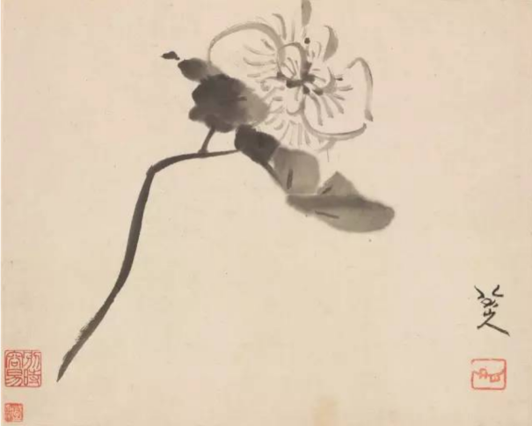
Hibiscus 《芙蓉图》
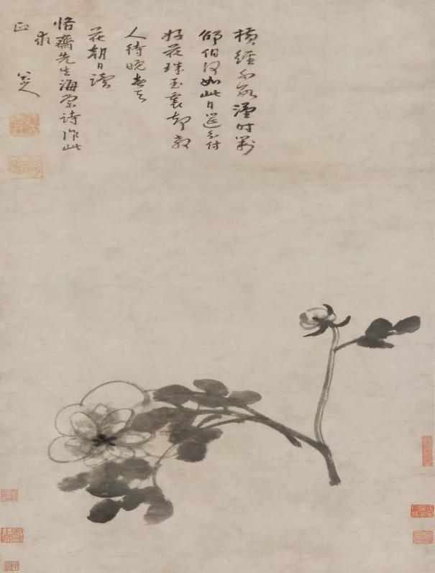
Peonies 《芍药图》
八大山人 Bada shanren (Zhu Da)
水墨画 wash painting ,ink and wash

Ⅲ. Terms and Expressions
Zhu Da | 朱耷（八大山人） | Qingyunpu | 青云谱
Zheng Banqiao | 郑板桥 | Eight Eccentrics of Yangzhou | 扬州八怪
Xu Beihong | 徐悲鸿 | Wu Changshuo | 吴昌硕
Li Kuchan | 李苦禅 | Qi Baishi | 齐白石
Chen Shizeng | 陈师曾 | Xu Wei | 徐渭
Shi Tao | 石涛 | Hu Qinyuan | 胡沁园

References
https://baike.baidu.com/item/%E9%BD%90%E7%99%BD%E7%9F%B3/234940
https://baike.baidu.com/item/%E6%9C%B1%E8%80%B7/501139?fromtitle=%E5%85%AB%E5%A4%A7%E5%B1%B1%E4%BA%BA&fromid=84074
https://www.dpm.org.cn/fully_search/%E6%9C%B1%E8%80%B7

