Contemporary Translation Theories
What is translation theory?
“Translation Theory”is and is not a new fields; though it has existed only since 1983 as a separate entry in the Modem Language Association International Bibliography, it is as old as the tower of Babel. Some literary scholars claims never to have heard of it as a subject in and of itself, others, who may themselves translate, claim to know all that they need to know. Anyone working ‘’monolinguistically ‘’ may support no need for translation theories; yet translation inheres in every language by its relationship to others signifying systems both past and present. Translation theory is central of anyone interpreting literature, in an historical period characterized by the proliferation of literary theory is becoming increasingly relevant to all of them.
What is contemporary translation theory?
Roman Jakobson breaks the field down into three areas: Intralingual translation, a rewording of signs in one language with signs from the same language; interlingual translation or the interpretation of signs in one language with signs from another language (‘’ translation proper’’);and intersemiotic translation,or the transfer (‘’transmutation”’) of the signs in one language to non-verbal sign systems ( from language into art or music). All of Jakobson’s fields mutually reinforce each other, and, accepting this definition, one can easily see how translation theory can quickly enmesh the student in the intersemiotic network of language and culture, one touching on all the disciplines and discourses.

CONTEMPORARY THEORIES TO TRANSLATION
There are six main approaches within contemporary translation theory: the sociolinguistic approach, the communicative approach, the hermeneutic approach, the linguistic approach, the literary approach and the semiotic approach.

1. THE SOCIOLINGUISTIC APPROACH
According to the sociolinguistic approach to translation, the social context defines what is and is not translatable and what is or is not acceptable through selection, filtering and even censorship. According to this perspective, a translator is inevitably the product of his or her society: our own sociocultural background is present in everything we translate.
2. THE COMMUNICATIVE APPROACH
This perspective is referred to as interpretive. Researchers like D. Seleskovitch and M. Lederer developed what they called the “theory of sense,” mainly based on the experience of conference interpreting. According to this perspective, meaning must be translated, not language. Language is nothing more than a vehicle for the message and can even be an obstacle to understanding. This explains why it is always better to deverbalize (instead of transcoding) when we translate.

3. THE HERMENEUTIC APPROACH
The hermeneutic approach is mainly based on the work of George Steiner, who believes that any human communication is a translation. In his book After Babel he explains that translation is not a science but an “exact art”: a true translator should be capable of becoming a writer in order to capture what the author of the original text “means to say.”
4. THE LINGUISTIC APPROACH
Linguists like Vinay, Darbelnet, Austin, Vegliante, and Mounin, interested in language text, structuralism, and pragmatics, also examined the process of translating. According to this perspective, any translation (whether it’s a marketing translation, a medical translation, a legal translation or another type of text) should be considered from the point of view of its fundamental units; that is, the word, the syntagm and the sentence.
5. THE LITERARY APPROACH
According to the literary approach, a translation should not be considered a linguistic endeavor but a literary one. Language has an “energy”: this is manifested through words, which are the result of experiencing a culture. This charge is what gives it strength and ultimately, meaning: this is what the translation-writer should translate.
6. THE SEMIOTIC APPROACH
Semiotics is the science that studies signs and signification. Accordingly, in order for there to be meaning there must be collaboration between a sign, an object and an interpreter. Thus, from the perspective of semiotics, translation is thought of as a way of interpreting texts in which encyclopedic content varies and each sociocultural context is unique.
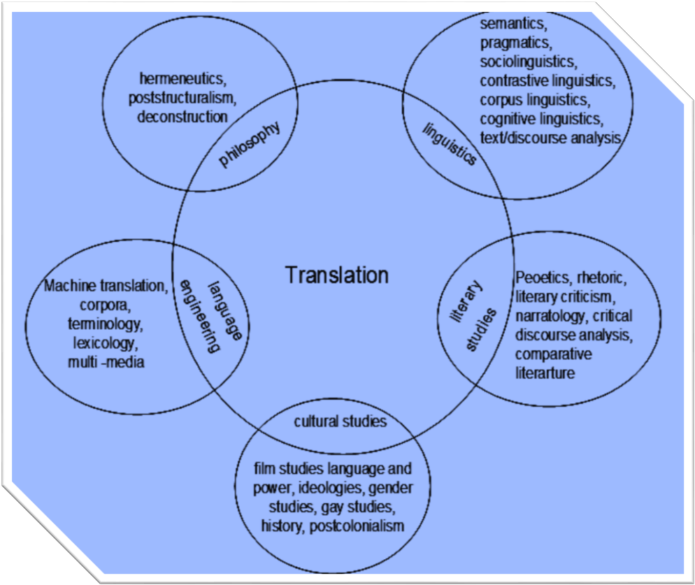
Conclusion:
During the last thirty years, the field of translation has exploded with multiple new theories. Contemporary Translation Theories examines five of new approaches . The translation workshop, the science of translation, translation studies, polysystem theory, and deconstruction.
References:
Edwin Gentzler 2001 Contemporary Translation Theories

