- Chinese Movies：Brief History and Genre
History and genre(类型）are the two basic parameters(标准) used when categorizing films: We want to know both when a film was produced and what of film it is.
The history of film is simplified by its shortness. In the case of Chinese Movies, it is enough to talk about five major historical periods — those of beginnings, second golden age, early communist era, films of the Cultural Revolution and rising of the fifth generation. Films from a given period of film industry tend to display certain characteristic features.
Genres are the categories into which, on the basis of shared characteristics, we place artistic, musical, literal or cinematic works. There is a considerable debate concerning how the concept of the “genre” should be defined, which genres actually exist, and how individual films should be classified. Nevertheless, the concept of the genre remains the best way of organizing films into meaningful groups, and also a useful guide as to potentially significant elements of a given film.
Beginnings
Although shadow puppet play(皮影戏) has a long history of more than a thousand years in China, movie motions were introduced to China in 1896. China was one of the earliest countries to be exposed to the medium of film, due to Louis Lumière sending his cameraman to Shanghai a year after inventing cinematography.
Second golden age
The film industry continued to develop after 1945. Production in Shanghai once again resumed as a new crop of studios took the place that Lianhua and Mingxing studios had occupied in the previous decade.
Early Communist Era
With the communist revolution in China in 1949, the government saw motion pictures as an important mass production art form. The Communist regime solved the problem of a lack of film theaters by building mobile projection units which could tour the remote regions of China, ensuring that even the poorest could have access to films.The thawing of censorship in 1956–57 (known as the Hundred Flowers Campaign) and the early 1960s led to more indigenous Chinese films being made which were less reliant on their Soviet counterparts.
Films of the Cultural Revolution
During the Cultural Revolution, the film industry was severely restricted. In the years immediately following the Cultural Revolution, the industry tried to revive crowds by making more innovative and “exploratory” films like their counterparts in the West. In the 1980s, many popular thriller and martial arts films were socially unacceptable. Open criticism of certain past Communist Party policies was encouraged by Deng Xiaoping to reveal the excesses of the Cultural Revolution. Many scar dramas were made by members of the Fourth Generation whose own careers or lives had suffered during the events in question, while younger, Fifth Generation directors tended to focus on less controversial subjects of the immediate present or the distant past.
Rising of the Fifth Generation
Younger Fifth Generation directors tended to focus on less controversial subjects of the immediate present or the distant past. Diverse in style and subject, they share a common rejection of the socialist-realist tradition worked by earlier Chinese filmmakers in the Communist era. Fifth Generation filmmakers reacted against the ideological purity of Cultural Revolution cinema. By relocating to regional studios, they began to explore the actuality of local culture. Instead of stories depicting heroic military struggles, the films were built out of the drama of ordinary people’s daily lives. They adopted complex plots, ambiguous symbolism, and evocative imagery.
These films came with a creative genres of stories, new style of shooting as well, directors utilized extensive color and long shots to present and explore history and structure of national culture.

Categorization of Genres
The table below can be roughly used to identify genres:
Genre | Defining Criteria | Example
Biology  Fantasy（奇幻片）  Sports  Romance  Science fiction  Crime  War Film  Martial Arts  Epic  Disaster（灾难片） | Subject  Matter | Jiao Lulu(《焦裕禄》)  The Sun also Rises(《太阳照常升起》)  Lost but Win(《风速极战》)  Go Away Mr.Tumor (《滚蛋吧！肿瘤君》)  Amazing (《神奇》)  A World without Thieves (《天下无贼》)  Forever Young (《无问西东》)  I am Bruce Lee (《我是李小龙》)  To Live (《活着》)  The Wandering Earth (《流浪地球》)
Action  Dance | Formal Criteria | Ip Man (《叶问》)  Youth (《芳华》)
Comedy  Horror  Thriller | Affective Response | Flirting Scholar (《唐伯虎点秋香》)  The House never Dies (《京城81号》)  The mirror (《魔镜》)
- Chinese Movies：Some Achievements
The first Chinese film, Dingjun Mountain(《定军山》), was made
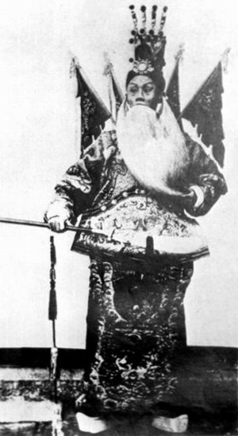
in 1905. The film consisted of a recording of Peking opera superstar Tan Xinpei dressed in the character Huang Zhong and singing some arie from the Peking opera of the same name. The play is a dramatised account of Battle of Mount Dingjun (219 AD) and based on an episode in the 14th-century historical novel Romance of the Three Kingdoms.
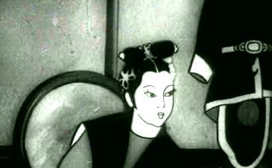
Princess Iron Fan(《铁扇公主》)(1941), the first Chinese animated feature film was released. It influenced wartime Japanese animation and later Osamu Tezuka.The story was liberally adapted from a short sequence in the popular Chinese novel Journey to the West. Princess Iron Fan is a main character. Specifically, the film focused on the duel between the Monkey King and a vengeful princess, whose fan is desperately needed to quench the flames that surround a peasant village.
Farewell My Concubine (《霸王别姬》)
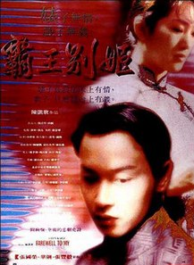
won the Palme d'Or at the 1993 Cannes Film Festival. It is a 1993 Chinese historical drama film directed by Chen Kaige(陈凯歌), starring Leslie Cheung(张国荣), Gong Li(巩俐), and Zhang Fengyi(张丰毅). Adapted for the screen by Lu Wei (芦苇)based on the novel by Lilian Lee(李碧华), the film is set in a politically tumultuous 20th-century China, from the early days of the Republic to the aftermath of the Cultural Revolution. It chronicles the troubled relationships between two Peking opera actors and lifelong friends Cheng Dieyi (Cheung) and Duan Xiaolou (Zhang), and Xiaolou's wife Juxian (Gong).

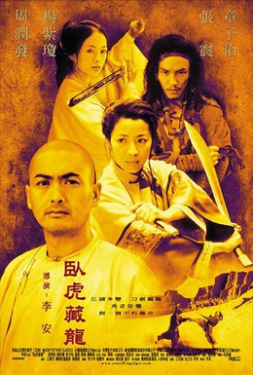Crouching Tiger, Hidden Dragon (《卧虎藏龙》) is a 2000 wuxia（武侠） film directed by Ang Lee （李安）and written by Wang Hui-ling（ 王蕙玲）, James Schamus and Kuo Jung Tsai（蔡国荣）. The film features an international cast of actors of Chinese ethnicity（华人）, including Chow Yun-fat（周润发）, Michelle Yeoh（杨紫琼）, Zhang Ziyi （章子怡）and Chang Chen（张震）. It is based on the Chinese novel of the same name serialized between 1941 and 1942 by Wang Dulu（王度庐）, the fourth part of his Crane Iron pentalogy（鹤铁系列小说）.
references
- An Introduction to Film Studies. London: Routledege.
- Andrew Lynn. Appreciating Cinema.
- https://en.wikipedia.org/wiki/Cinema_of_China

Questions
- What is the name of the first Chinese film?
- What is the name of the first Chinese animated feature film?
- Do you know who directed the film Farewell My Concubine?
- Do you know who directed the film Crouching Tiger, Hidden Dragon?
- Which book is the film Princess Iron Fan(《铁扇公主》)based on?

