Industrial Structure and Employment of Japan facing the article “Land der Ausgegrenzten”

Japanese economical structure today faces severe challenges towards its’ future positions on a global and intra perspective with their classical Japanese Model of industrial structure. Issues regarding employment and labour market have an immense influence on policies, politics and Japan’s status in the global market straightly to Japan’s historical development.

As Muhammad (2009) stressed the rapid growth in Japan’s economy from the 1950s until the Burst of the Bubble in the 1990s by the combined factors of “government policies, the efforts of the people and the contribution of the business community” (2009, p.23) one can conclude the impact on the classical Japanese Model. Not only did Japan use consumption chances like America’s favourable trade policies and the Olympic Games until the 1960s, but Japan valued an healthy environment as well and cared for social issues and securities. The establishment of a social security system, due to several shocks in the 1970s, formed Japanese economic thinking, which was even more influenced with the Burst of the Bubble leaving high public debt, an unproductive domestic sector and a rotten banking system for future generations to deal with (as further described in Lukas and Saito, 2009).

The classical Japanese Industrial Model is based on three pillars: Life-Time-Employment (LTE), Seniority-plus-Merit (Nenko) and Enterprise Unionism/trade unions. The idea of the state and companies is to provide well fare for citizens/employees. Security and social protectism are given overall advantages to employees, who return the “given” job security with their workforce and company loyalty.
Unfortunately, LTE increase inflexibility on the labour market and in the company’s HR-Management, which may even lead to serious problems in globalization-based changes and crises. This management strategy consists of hiring employees (mainly male full-time workers) for their entire career with a mutual contract that additionally secures specific incentives after their retirement. What if, caused by economic challenges, the company faces serious sales issues that may lead to bankruptcy, as it almost did to Hitachi ? If the company refuses to adapt to more “western” ways it may cost more jobs than could have been saved with the increasing influence of globalized markets. Another option remains in downsizing or leaving the global market space and returning to one’s own (almost) saturated market, which may lead into different problems.

Especially the second pillar, the Seniority-plus-Merit (Nenko), is discussed widely. Kayama and Kusayanagi (2009) describe that concept as follows: “Structured upon the basis of life-time employment, during which long years of service and loyalty to the company are expected, the process of promotions and raises in wages is very slow. Under life-time-employment, the longer the employee works and the older the employee is, the more responsibility and pay he receives.” (p.121). It remains questionable of how productive, efficient and work-willing people in their mid 50s are, especially how qualified in state-of-the-art knowledge and motivated compared to a mid 30-year-old worker.
Since on-the-job training is the usually preferred job education in the group orientated Japan that is settled by older workers training the younger ones (called Senpai-Kouhei relationship), it may be true that intangible, tacit knowledge can’t be transposed in a more efficient way than peer to peer. Hence, a performance-based salary system may ruin on-the-job education as well as the strongly enforced community feeling a corporation is building up. Still it is arguable, that result orientation instead of Nenko may support global working firms in a secure way than the classical Japanese model. For that, it is suggestible to proceed in the following system: Widely on Japanese side discussed disadvantages are seen as in insecurity, questionable evaluation of individual performance, less corporation and short term vision that go along with the performance-based evaluation. But if the Japanese working culture with its strongest benefits (concepts of “ganbaru ”, “gaman ”, “giri ”, “harmony”, “hone and tatamae ”, “uchi-soto”, which are identifying points of Japanese culture) is combined with performance-based evaluation on sections, team, and a specific group, it would benefit the whole company due to result orientation without disturbing Senpai-Kouhei relationships and on-the-job-training.
Further the distribution of salary would not depend on age, but the team individuals receive the same incentives. This “team-performance-based system” would end in “working” and “waiting” people, e.g. in Germany, and may raise rather dissatisfaction among workers, due to unfair inner teamwork distribution. But Japan seems different regarding this issue, and may favour team over individual orientation.

As the last of the three pillars, Enterprise Unionism can be summarized as a “second management” ensuring job security and good working conditions for full-time employees by strengething the collective corporate identity. This is an important point, since Unions are not working on an industrial level as e.g. in Germany, but an intra-company-orientated level. It is arguable whether they really succeed their goals, since they differ between workers inside the company. Especially with the upcoming trend of part time jobs, “freeters”, etc., it is questionable whether its successful to make a distinction between contracts of employees. 66,3% of overall Japanese companies hire irregular workers. With 66% of regular employees with an income of average 311,500 Yen per month, 34% of irregular worker with an equal working schedule but fewer social benefits and an average income of 198,100 Yen per month are a resolution. Not only in income and social welfare do Part-timers endure immense differences from full-time workers, but also in terms of status in the company. If the Unions are made for good working conditions on enterprise level, why exclude enterprise workers just because of contract distinctions? Hence, the unionization rate of Japan is decreasing alongside with the increasing rate of part-time jobbers: With 56% of the employees being in a Union in 1949, it decreased to 35% in 1970 and even 18% in 2010. It poses the question why to maintain Enterprise Unions?

Kayama and Kusayanagi (2009) describe advantages as following: Unions maintain harmony within the corporation and secure cooperation between full-time workers and management. Since they are fewer industrial conflicts, an enterprise-based approach seems sufficient. On the other hand they have to face disadvantages as in weak bargaining power and diverse interest (as in the difficulty to maintaining unity and solidarity with raising Western-influence employees and changing contract policies). Further is the limited capacity to protect workers to mention. It remains difficult to decide whether one or the other side overweights the other, although the declining trend of participation may signalize less interest and benefits from that third pillar.

Regarding the classical three-pillars-based Japanese industrial relations model, the article of Japan’s women lacks some valuable background information to fully understand the contemporary situation of Japanese women. The article concluded that one reason Japan’s economy is stagnating lies in the low career opportunities for Japanese women.
What the article isn’t covering, are the basic Japanese cultural ideas that root deep into the cause of the unused female workforce. As Kobe and McKinsey (1998) described, Japanese culture can be comprehended in three main points on which everything else growths from: firstly Collectivism/Group Orientation, secondly social control/conformity and thirdly its vertical structure.

The collectivistic Japanese society values duties on the group higher than the individual rights. With their collectivistic value system a specific limit is set on individual interest and a collective identity is formed, that is either based on category-based intergroup orientation or network-based intragroup orientation. Through cultural differences in psychological processes it is empirical stated that the Western world tends to rather a category-based intergroup orientation and East Asia to a network-based intragroup orientation, which leads to the conclusion, that the nature of collectivism is just different but everywhere to find. In the Japanese case the deep-rooted underlying cultural heritage and religious traditions form nowadays actions. While the West is mainly based on Greek civilization and Protestantism/Christianity, Japan is influenced by Buddhism and Confucianism that underline social harmony, filial Peity and hierarchy. Whereas the West generated a more individualistic perspective and the question of oneself due to their ancestors as described by Kerbo and McKinstry (1998).
The Food Accumulation system is another theory by Kerbo and McKinstry (1998) that may stress the collectivistic culture of Japan: Due to high food accumulation of rice community formation, social forms and rules were necessary to ensure nutrition for the group, while the Western hunting society stressed independence and creativity with the low food accumulation in hunting.
All of that group-orientated formation needs the social control or conformity to ensure continuation. Yoshio Sugimoto (2010) called it a “friendly authoritarianism”, in which small groups work as a basis of mutual surveillance and deterrence of deviant behaviour to stress a collective responsibility. Since 1597, due to Toyotomi Hideyoshis enforcement, “goninguni” were formed, five individuals or families to find Christians for a sufficient containment of Christianization and ensure social harmony inside Japanese neighbourhoods. Unofficial neighbourhood corporations are working until today that could have lead to a specific discouragement of spontaneity and inculcation of social morals found today.
These points describe Japan as a culture of Shame, rooted in their polytheism. Not the kind of action is judged but whether it will bring shame on the community and is based on specific obligations to people and institutions every cultural member has. The “public eye”, though a normal basic social norm to strengthen community life, is institutionalized in Japan and effects lifestyles, individual decision making likewise as corporation’s behaviour with employees.

As a last point, the vertical structure developed from the traditional family model as e.g. Hendry (2003) and Rebick and Takenaka (2006) described, influences contemporary Japanese society. The basic household (ie system) is a patrilineal extended family system that traditionally evolved in living with more people than your own children. Family line is more important than bloodline, though a family was seen as a group of individuals based on the horizontal martial relationship, the family system was politically institutionalized and by the Meiji Government modernized into a taxation and conscription unit. It remained a male dominated system with gender inequality to ensure economic advantages by maintaining family property and to serve the society in supplying labour force for industrial growth and military, as well as a well fare system and social safety net. Post-war the civil code was revised due to outside forces: gender equality and equal inheritance was brought upon Japanese women that clashed with the so far cultural understanding. Recent trends of increasing international marriages (1980: 0,9% 2008:5,6%), increasing divorce rates (2008:35%), further individualization (weakened family relationships, less family cohesion) and declining marriage rates due to strong gender ideology causing problems, hypergamy (a higher status of men are wanted), declining pressure for marriages and better educated women are results.

As the Global Gender Gap Report (2012), Ogasawara (1998) and Mikanagi (1998) stated a certain gender inequality is visible. The economic participation and opportunity is divided into labour force participation, wage equality, income, top positions and professionals. Further shows the educational attainment the level of literacy, finished primary, secondary and tertiary education. Health and survival (Females reach statistically the average age of 78, while males reach the average age of 73) and political empowerment in terms of participation in parliament and division in ministers are other categories to be pronounced.

Economic Participation and Opportunity
Category | Male | Female
Labour Force Participation | 84% | 62%
Wage equality |  | Female earn 60% of average male income
Income | Average 40.000$ | Average 22.000$
Top Positions | 91% | 9%
Professionals | 53% | 47%
Educational Attainment Political Empowerment
Category | Male | Female
Literacy | 99% | 99%
Finished Primary Education | 99% | 100%
Fin. Secondary Education | 99% | 100%
Fin. Tertiary Education | 63% | 56%
Category | Male | Female
Participation in Parliament | 89% | 11%
Division in Ministers | 88% | 12%

Source: WEF Global Gender Gap Report 2012

Seeing the number of the World Economic Forum’s Gender Gap Index, Japan reaches the position of 102 out of 135 countries, as stated in the newspaper article. What the article is not fully covering is the answer of why inequality evolves in Japan, the third largest economy in the world.
The Japanese tendency to preserve traditions, the suppression by conservative corporate culture, the huge avoidance of conflicts, women’s low preference of LTE and the strong gender roles emphasis the status quo. Five main factors seem to support manifesting gender inequality 1) employment status 2) long career blank 3) limited career opportunity 4) employment policies and 5) taxation policies.
Due to family boundaries women rather tend to work part time than dedicating their life for climbing the latter for LTE.
Employment Status | Male | Female
Full-Time | 81% | 46%
Part-Time | 19% | 54%
Until now, 70% of women quit their job after childbirth – a high number that is just slowly decreasing. These factors support the “M”-curve, though other countries rather have a “U”-shaped-curve regarding women’s behaviour towards employment as visible in the attached picture.
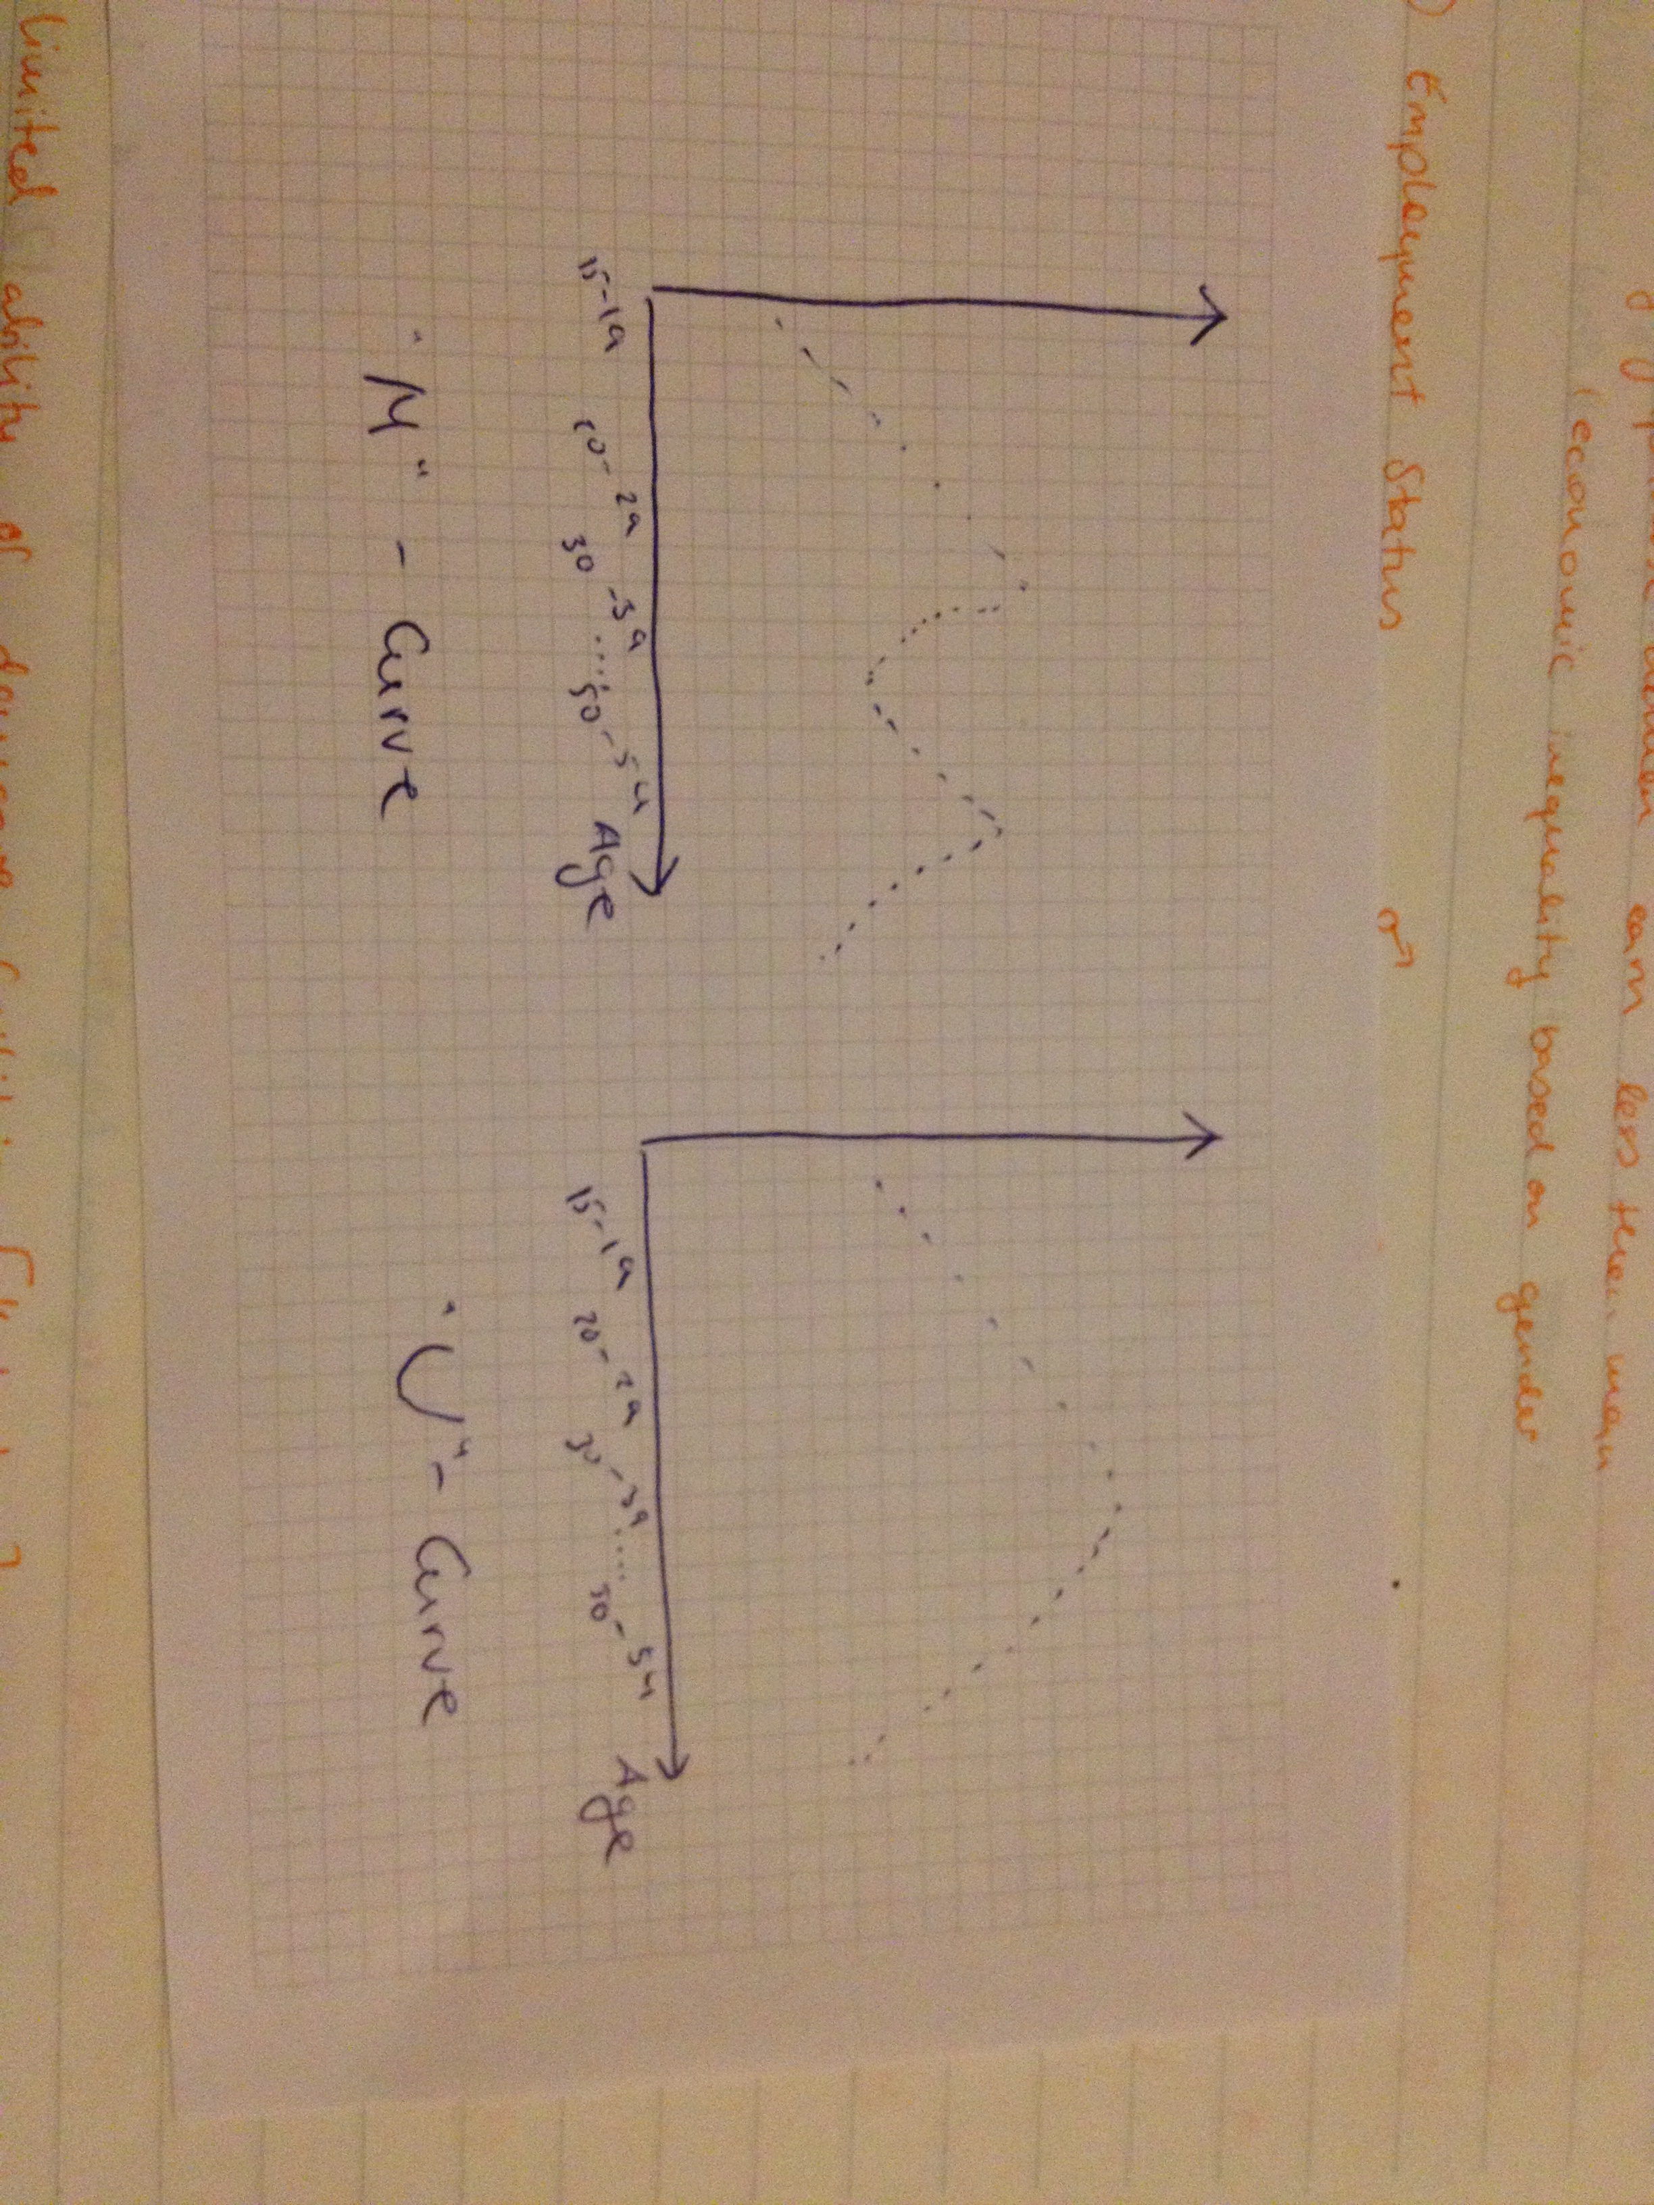
Source: visualized by Nathalie Bonk.
This specific M-Curve duel out of limited availability of day-care facilities, the usual long working hours in company cultures and the limited support of e.g. housework sharing, developed out of the strong gender roles. Women face due to their job-quitting quote the stereotype to be less productive, working fewer working hours and being not suitable for preferable higher job positions.

What the article is not mentioning is the traditional Japanese career track policy. With two different tracks (the administrative “ippanshoku” and the managerial track “sogoshoku”) one has to decide from the beginning where to apply and the company has to decide who to assign to each track. Both are facing different income levels, different developments in skills and responsibility as well as different working hours. A trend for men choosing the managerial and women choosing the administrative path seems obvious due to above-mentioned reasons. A slow change is visible due to changing statistical numbers, but it remains slow as the Gender Gap Report visualizes. Further has the impact of state policy to be addressed in terms of childcare policies, elderly care and education. Alongside with the still favourable traditional Japanese role model its is necessary for women to quite their job in order to support social well fare with educating their children and caring for their elderly. There are not enough institutions to take care of these points besides each family by themselves.

Last points to mention are the current employment and taxation policies that favourable women to stay at home or earn a low incomes per year as Mikanagi (1998) and Schiffer and Inada (2009) stated. If the woman is earning approx. 1.03 million Yen (about 10.300€) per year, she has no income tax to pay, free health care for which no contributions are necessary and different tax benefits for her spouse. If her income exceeds 1.03 million Yen, her husband needs to e.g. pay higher taxes. Considering the savings in that taxation policy for households, it attracts women to work less. But diverse aspects concerning the profitability of that tax system for the overall social welfare are questionable. With fewer taxpayers for e.g. pension, this system may collapse in future due to Japan’s problem with its hyper aging society. To preserve the current size of population, it is said for Japan to increase their total fertility rate (TFR) from current 1,37 into 2,08 and enhance the argument in the article.

Japan is still facing problems regarding the public debt (connected to the “aging population” issue, a rather loss-making tax system partially still from Meiji period and the problem of overcapacity) and the questionable domestic sector major challenges are to solve in the future. It may be possible that in consequence of traditional based thinking and avoidance of change, the Japanese economy might loose its position in the global rank of important economies internationally and face even severer issues within Japan. Since change is continuously and growth opportunities are still there, from an out-of-Japan-perspective, all Japan may have to do is to stop being isolated in case of import rates, ratio of foreigners working in Japan and to increase female workforce rates to face opportunities and challenges. Hitachi, Nissan, Uniqlo and Ryohin Keikaku are further examples for companies breaking away from the solely classical model after facing more or less severe issues, partially close to bankruptcy as in Hitachi’s and Nissan’s case. By adapting to more Western management styles, an increased employment of women and change they managed to overcome those issues.

It is stressed by Cedric Herring (2009) as well as in the article, that higher gender diversity may lead to higher market share, profitability, more customers and more corporate revenue. What isn’t mentioned lays in the culture beneath the formal rituals to welcome new employees into the company and the still traditional-orientated mind-sets in which Japanese act. Gender inequality as mentioned in the article may preserve if no changes into Japanese tendency to hold onto traditions, women’s low preference of LTE compared to men, the suppressions by conservative corporate culture and maintenance of stringent employment paths. Furthermore the tendency to avoid conflicts and strong gender roles, supervised by the public eye may slow down changes into Japan being a gender-equal country, as the Global Gender Report and the newspaper article partially describe.

Reference List:
Aaron Schiffer and Yui Inada. 2009. Demographic Changes. Chapter 5 Parissa Haghirian (eds.). 2009. J-Management: Fresh Perspectives on the Japanese Firm in the 21st Century. Pp. 73-91.

Akihiro Kayama and Momoko Kusayanagi. 2009. Human Ressource Management. Chapter 7. Parissa Haghirian (eds.). 2009. J-Management: Fresh Perspectives on the Japanese Firm in the 21st Century. Pp.118-146.

Alison Onishi. 2009. Knowledge Management. Chapter 10. Parissa Haghirian (eds.). 2009. J-Management: Fresh Perspectives on the Japanese Firm in the 21st Century. Pp.204-225.

Baktash Muhammad. 2009. Post-War Economy. Chapter 2 Parissa Haghirian (eds.). 2009. J-Management: Fresh Perspectives on the Japanese Firm in the 21st Century. Pp.4-44.

Cedric Herring. 2009. Does Diversity Pay?: Race, Gender, and the Business Case for Diversity. American Sociological Review. April 2009. Vol. 74, No. 2. Pp. 208-224

Chie Nakane. 1992. Japanese Society. Charles E. Tuttle Publishers, Tokyo, 8.Ed. Chapters 1-3.

Daisuke Wakabayashi. 2012. Hitachi President pushes for a profit turnaround. The World Street Journal. May 14, 2012. Pp.14-15.

Felix Lill. 2013. “Land der Ausgegrenzten”. DIE ZEIT. July 25, 2013. No.31. p.20.

Harold R. Kerbo and John A. McKinstry. 1998. Modern Japan. McGraw-Hill. Chapters 1-4.

Japan Institute for Labor Policy and Training. 2012. Labor Situation in Japan and Analysis. Chapters 2-3.

Joy Hendry. 2003. Understanding Japanese Society. Routledge. Chapter 2.

Mari Sako and Hiroki Sato. 1997. Japanese Labour and Management in Transition: Diversity, Flexibility and Participation. Routledge.

Marcus Rebick and Ayumi Takenaka. 2006. The Changing Japanese Family. Routledge. Chapters 1&3.

Manuel Lukas and Miho Saito. 2009. Structural and economic changes. Chapter 4. Parissa Haghirian (eds.). 2009. J-Management: Fresh Perspectives on the Japanese Firm in the 21st Century. Pp. 47-72.

Noboyuki Honna and Bates Hoffer. 1986. An English dictionary of Japanese culture. Tokyo, Japan: Yuuhikaku Publishing.

Nodoka Kobayashi, Kaoru Miki and Delphine Pilate. 2009. The Japanese Firm as an intercultural workplace. Chapter 14. Parissa Haghirian (eds.). 2009. J-Management: Fresh Perspectives on the Japanese Firm in the 21st Century. Pp.300-324.

Peter Petersen. 2001. “A Graying World: The Danger of Global Aging.” Harvard International Review. Vol.23. Harvard International Relations Council, Inc. July 28.

Takashi Oshio. 2008. “The Declining Birthrate in Japan.” Japan Economic Currents. No.69. March.

World Economic Forum. 2012. The Global Gender Gap Report. WEF. http://reports.weforum.org/global-gender-gap-2012/ “Japan”. Pp.212-213.

Yuko Ogasawara. 1998. Office Ladies and Salaried Men: Power, Gender and Work in Japanese Companies. University of California Press.Introduction & Conclusion.

Yumiko Mikanagi. 1998. “Japan’s gender-biased social security policy.”Japan Forum 10(2). Pp. 181-196.

Yoshio Sugimoto. 2010. An Introduction to Japanese Society. Cambridge University Press. Chapter 4. Pp.111-123.

Trends as mere use of performance-based systems, shortage of official working hours and increase in irregular employments.
E.g. migration issues, the unproductive usage of women workforce. See further Kayama and Kusayanagi (2009), Lukas and Saito (2009).
In consequence of inefficiency, overcapacity on the low-marge domestic market, and the habit not to fire employees as further described in my first paper.
As in terms of e.g. cost efficiency, fast decisions if a crisis accrues, performance-based salaries instead of seniority-based systems, open labour markets for job-hoppers and not only university freshmen.
See further Onishi (2009).
With the firm as a community it ensures loyalty, commitment, social harmony and good personal relations with the employees, who are supposed to work with each other for the upcoming 20-40 years. It results in an almost typical behaviour in corporation environment-regardless the company’s size.
To work hard and make serious effort.
Being patient, tolerant, being able to endure things.
Giri is described as a valued standard in human relationships, as it is practiced with the amae and amaeru – concept: people take care of their group- members and are taken care of. See further Kerbo and McKinstry, Chapter 2(1998).
The concept of harmony, which is strongly related on Shinto principles, is a practical behavioural concept to ensure peace and harmony in a group. (Nakane, 1992).
Defined as: „These two words are often considered a dichotomy contrasting genuinely-held personal feelings and opinions from those that are socially controlled. Honne is one`s deep motive or intention, while tatemae refers to motives or intentions that are socially-tuned, those are shaped, encouraged, or suppressed by majority norms.“ Honna and Hoffer (1986) p.94. And read further in Kerbo and McKinstry, Chapter 2(1998).
The uchi-soto concept is a further development of the ie-concept. Uchi resembles a social group, even family-like, not only to deepen the contrast between people outside (soto) that allows a feeling of security for members of uchi. Read further in Nakane (1992).
Freeters are a consequence of the not-flexible-enough labour market and habit of LTE. The Japanese government tried to loosen the labour market up with reforms, that led to even more disadvantages for these part-timers and increased not only poverty, but also weakened Japan’s taxation income. Further reading in Madrid, Tanaka and Taylor (2009).
„Land der Ausgegrenzten“ by Felix Lill on 25.Juli 2013 in „DIE ZEIT“ No.31.
Read further Oyserman, Coon and Kemmelmeier (2002) as well as Takano and Osaka (1999) for their meta-analysis that e.g. Americans were no less collectivistic than East Asians, although Americans were more individualistic than East Asians.
With the West as a culture of guilt, in which universal standards for good/evil are know and based on monotheism, e.g. the ten commandments, specific actions remain misunderstood between those cultures, since the underlying value system works mainly unconsciously. Read further Nakane (1992), Kerbo and McKinstry (1998).
In Western cultures it is the opposite way round. Historically seen, adaptions were on of the least solutions to extend family lines – one may rather divorce the no-son-bearing wife and find another partner. See further Nakane (1992) p.18.
Schiffer and Inada (2009), p.82.
See for further reading Kayama and Kusayanagi (2009) and Madrid, Tanaka and Taylor (2009).
With 7% oft he overall society being over 60, a society is called aging society, with 14% turning into an aged society and with 21% and over a hyper aged society in which Japan falls with current 23,3%. See Petersen (2001) and Schiffer and Inada (2009).
See further Oshio (2008).
Read further Kobayashi, Miki and Pilate (2009).

