The Development of Machine Translation
吴漠汀教授（Martin Woesler）Session 3, 2020 年 10 月 12 日

- Introduction to Machine Translation
Machine Translation (MT) is the process of using a computer to convert one natural source language into another natural target language. It is a branch of computational linguistics, one of the ultimate goals of artificial intelligence, and has important scientific research value.
At the same time, MT has important practical value. With the rapid development of economic globalization and the Internet, MT has played an increasingly important role in promoting political, economic, and cultural exchanges.

- The Development of Machine Translation
Generally, the development of MT can be divided into the following stages: proposal (1933-1949); early stage (1949-1964); setback (1964-1975); recovery (1975-1989); development (1993-2006); prosperity (2006-present). Here is a graph of MT developments.
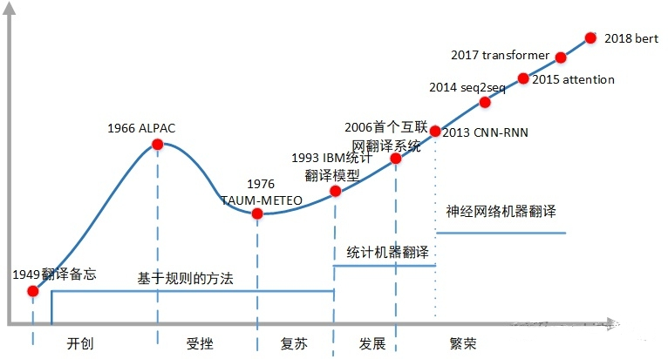

2.1. Proposal (1933-1949)
The history of MT research can be traced back to the 1930s. In 1933, French scientist G.B. Artsouni put forward the idea of using machines for translation. In 1946, the world's first modern electronic computer, ENIAC, was born. Soon afterward, American scientist Warren Weaver, a pioneer in information theory, proposed the idea of using computers for automatic language translation in 1947. In 1949, he published the famous memorandum, formally proposing the idea of MT.

2.2. Early-stage (1949-1964)
In 1954, Georgetown University, in collaboration with IBM, used the IBM-701 computer to complete the English-Russian MT experiment. For the first time in history, the IBM-701 computer automatically translated 60 Russian sentences into English. But no one mentions that the samples obtained from these translations have been carefully selected and tested to eliminate ambiguity. During this period, the United States and the Soviet Union invested a lot of money in MT for military needs. It focuses on the language pair translation between English and Russian. The main objects of translation are scientific and technical documents, such as articles in scientific journals. A rough translation is enough to understand the basic content of the article. Due to economic needs, European countries have also given considerable attention. MT was booming during this period.

2.3. Setback (1964-1975)
However, just as everything is proceeding in an orderly manner, MT research, which is still in its infancy, suffers a blow. In 1964, the American Academy of Sciences established the Automatic Language Processing Advisory Committee. After two years of research, this committee published a report called Language and Machines (ALPAC-Report) in November 1966. The report completely denied the feasibility of MT and declared that "in the near or foreseeable future, there is no hope for the development of a practical MT system." Funding support for MT projects is recommended to stop. Affected by this report, various MT projects have dropped sharply, and MT research has experienced an unprecedented depression.

2.4. Recovery (1975-1989)
In the mid and late 1970s, with the development of computer technology and linguistics and the demand for social information services, MT began to recover and flourish. The industry has developed a variety of translation systems, such as Weinder, URPOTRAA, TAUM-METEO, etc. Among them, the TAUM-METEO system, which was jointly developed by the University of Montreal in Canada and the Translation Bureau of the Federal Government of Canada in 1976, is a milestone in the history of MT development, marking MT from recovery to prosperity.

2.5. Development (1993-2006)
This period is mainly about statistical machine translation (SMT). A translation model based on word alignment was proposed by IBM's Brown and Della Pietra in 1993. It marked the birth of modern statistical MT methods.
In 2003, Franz Och proposed a log-linear model and its weight training method. This article proposed a phrase-based translation model and a minimum error rate training method. The corresponding two articles Statistical phrase-based translation and Minimum error rate training in statistical MT marked the real rise of the SMT.

2.6. Prosperity (2006-Now)
In 2004, Franz Och joined Google and led to the development of Google Translate. In 2006, Google Translate was officially released as a free service and brought a big wave of SMT research. As of 2015, Google Translate has supported more than 100 languages. The quality of MT in this era has been greatly improved compared with previous methods, but there are still problems of inaccurate and influential translation. As the amount of data increases, the improvement of system performance gradually becomes difficult. After 2012, SMT gradually entered a plateau period.
As Franz Och left Google, deep learning technology began to rise and brought the birth of neural machine translation (NMT). NMT is still a translation technology based on text corpus, but uses a completely different model. In NMT, words are mapped to vectors in a high-dimensional vector space and mapped to the target language through neural networks. This method solves many problems of the traditional method, such as the length limitation of the ordering model, and its fluency is greatly improved compared with the previous method. In 2016, companies such as Baidu and Google successfully upgraded their online MT systems to neural network MT systems. Because its quality is generally considered to have crossed the practical threshold of many applications, it also triggered the second wave of MT. This is the era we are now in. Neural network MT has finally crossed the practical threshold in many specific application fields.

References

[1]Koehn, P. , F. J. Och , and D. Marcu . "Statistical Phrase-Based Translation." Conference of the North American Chapter of the Association for Computational Linguistics on Human Language Technology Association for Computational Linguistics, 2003.
[2]National Research Council. Automatic Language Processing Advisory Committee. "Language and machines; computers in translation and linguistics; a report." Methods in Molecular Biology 260(1966):73-82.
[3]Wolfram Wilss. The Science of Translation: Problems and Methods. 上海外语教育出版社, 2001.
[4]黎亚飞, and 张瑞华. "机器翻译发展与现状." 中国轻工教育 5(2019).
[5]许钧, and 穆雷. 翻译学概论. 译林出版社, 2009..

