J.C. Catford and His Translation Theory
Wei Honglang & Wen Xiaoyi

- J.C. Catford
J.C. Catford was born March 26, 1917 in Edinburgh, Scotland and died in Seattle in October 2009. He is a famous linguist and theoretician of translation, and his scholarly contributions span phonetics, phonology, dialectology, comparative linguistics, second language teaching, and translation theory. Catford's books and articles dealt with all aspects of phonetics, with the theory of translation, and with the application of linguistic knowledge to methods of second language instruction. His publications include over 60 articles and three books: A Linguistic Theory of Translation (Oxford University Press), Fundamental Problems in Phonetics (Edinburgh and Indiana University Press), and two editions of A Practical Introduction to Phonetics (Oxford).
- A Linguistic Theory of Translation
This book is based on his lectures given in the School of Applied Linguistics at Edinburgh University. Catford analyzes the process of translation through a linguistic theory which has the purpose of answering or solving problems that emerge when translation is undertaken. For him,all translation theories must lean on a linguistic theory, for it provides categories that can be used in the description of any language. In this book, he refers to the definition of translation, translation equivalence and translation shifts.
- The Definition of Translation
Translation may be defined as follows: the replacement of textual material in one language(SL) by equivalent textual material in another language(TL). The use of the term 'textual material' underlines the fact that in normal conditions it is not the entirety of a SL text which is translated, that is, replaced by TL equivalents. At one or more levels of language there may be simple replacement, by non-equivalent TL material. The term “equivalent” is clearly a key term, and we will discuss it next.
- Translation Equivalence
According to translation equivalence, he makes a further distinction between textual equivalence and formal correspondence.
4.1 Formal Correspondent
A formal correspondent is any TL category (unit, class, structure, element of structure, etc. ) which can be said to occupy the same place in the economy of the TL as the given SL category occupies in the SL as nearly as possible. In simplified terms, this means a TL piece of language which plays the same role in the TL system as an SL piece of language plays in the SL system. Thus, a noun such as fenêtre might be said generally to occupy a similar place in the French language system as the noun window does in English.
4.2 Textual Equivalent
A textual equivalent is any TL text or portion of text which is observed on a particular occasion to be the equivalent of a given SL text or portion of text. A textual translation equivalent is any TL form (text or portion of text) which is observed to be the equivalent of a given SL form (text or portion of text). A textual equivalent is thus: that portion of a TL text which is change when and only when a given portion of the SL text is changed.
For Example, the English textual equivalent for au dehors is out of the window; the formal correspondent outside is not used.
4.3 Formal Correspondence
Formal correspondence involves a comparison and description of the language systems (Saussure’s langue) and deals with the general and non-specific relationship between elements in two languages; textual equivalence focuses on the relations that exist between elements in a specific Source Text and Target Text pair (Saussure’s parole). It is clear that formal correspondence is approximate and can only be established ultimately on the basis of textual equivalence at some point. Textual equivalence is the aim of translation and precondition of formal correspondence, so translators should try to achieve textual equivalence rather than formal correspondence.
- Translation Shifts
By “shifts” we mean departures from formal correspondence in the process of going from the SL to the TL. A shift is said to occur if, in a given TT, a translation equivalent other than the formal correspondent occurs for a specific SL element.Two major types of “shift” occur: level shifts and category shifts.
5.1 Level shifts: A SL item at one linguistic level has a TL translation equivalent at a different level. Translation between the levels of phonology and graphology--or between either of these levels and the levels of grammar and lexis is impossible. Shifts from grammar to lexis and vice-versa is the only possible level-shifts in translation.
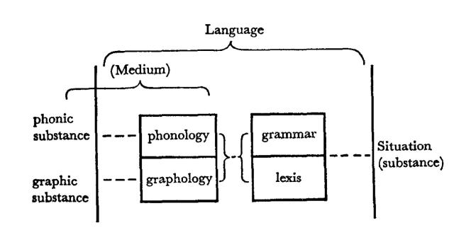
Eg. the rubbish is being disposed of.
(有人）正在处理这些垃圾。
5.2 Category shifts: Category shifts are departures from formal correspondence in translation. The fundamental categories of linguistic theory-applicable at least to the levels of grammar, phonology and probably graphology are unit, structure, class and system.
5.2.1 Structure-shifts: These are among the most frequent category shifts at all ranks in translation; they occur in phonological and graphological translation as well as in total translation（完全翻译）. In grammar, structure-shifts can occur at all ranks.
Eg. I saw you yesterday.
我昨天看见你了。
5.2.2 Class-shifts: Class means grouping of members of a given unit which is defined by operation in the structure of the unit next above. Class-shift occurs when the translation equivalent of a SL item is a member of a different class from the original item.
Eg. “...and that government of the people,by the people, for the people...”
“民有、民治、民享的政府”
5.2.3 Unit-shift：Changes of rank are departures from formal correspondence in which the translation equivalent of a unit at one rank in the SL is a unit at a different rank in the TL.
Rank： Sentence
Clause
Phrase\word group
Word
Morpheme
Eg. Surprisingly, politics is her favourite.
令人惊讶的是，政治课是她最喜欢的课程。
5.2.4 Intra-system shift：We use the term intra-system shift for those cases where the shift occurs internally, within a system; that is, for those cases where SL and TL possess systems which approximately correspond formally as to their constitution, but when translation involves selection of a non-corresponding term in the TL system.
Eg. How are you?
你好吗？/你们好吗？

References：
- Catford, J. A Linguistic Theory of Translation[M]. London: Oxford University Press, 1965.
- 穆雷.评卡特福德的《翻译的语言学理论》[J].外语教学,1990(02):37-42.
- 穆雷.卡特福德与《翻译的语言学理论》[J].语言与翻译,1993(02):54-56.
Electronic Resources:
- https://www.academia.edu/10513065/Book_review_A_Linguistic_Theory_of_Translation_J_C_Catford

