Decoding and Recoding
Definition
Decoding: The process of converting something from a coded form into a normal form.
Recoding: The process of converting from one code to another.

Theoretical Foundation
In Roman Jakobson’s article 'On Linguistic Aspects of Translation', he distinguishes three types of translation.
(l) Intralingual translation, or rewording (an interpretation of verbal signs by means of other signs in the same language).
(2) Interlingual translation or translation proper (an interpretation of verbal signs by means of some other language).
(3) Intersemiotic translation or transmutation (an interpretation of verbal signs by means of signs of nonverbal sign systems).
Having established these three types, of which (2) translation proper describes the process of transfer from SL to T L, Jakobson goes on immediately to point to the central problem in all types: that translation is only an adequate interpretation of an alien code unit and complete equivalence is impossible.
The translator, therefore, operates criteria that transcend the purely linguistic, and a process of decoding and recoding takes place. Eugene Nida’s model of the translation process illustrates the stages involved:

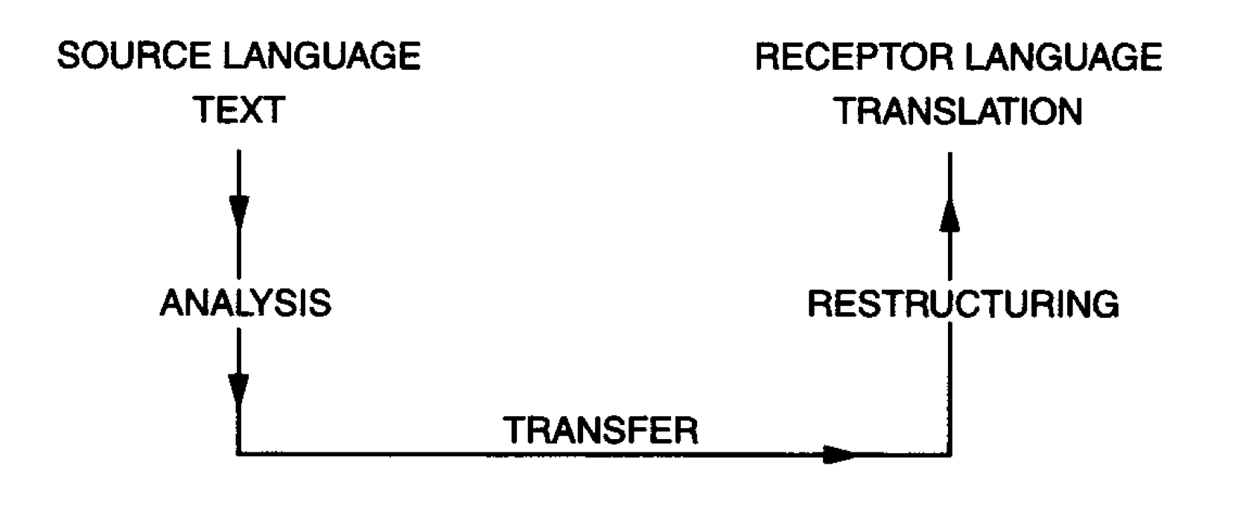

Example 1: Translating Yes into French, German and Italian

French: oui, si
yes German: jo
Italian: si

It is immediately obvious that the existence of two terms in French involves a usage that does not exist in the other languages. Further investigation shows that whilst oui is the generally used term, si is used specifically in cases of contradiction, contention and dissent.The English translator, therefore, must be mindful of this rule when translating the English word that remains the same in all contexts.
When the use of the affirmation in conversational speech is considered, another question arises. Yes cannot always be translated into the single words oui, ja or si, for French, German and Italian all frequently double or 'string' affirmatives in a way that is outside standard English procedures (e.g. si, si, si; ja, ja, etc). Hence the Italian or German translation of yes by a single word can, at times, appear excessively brusque, whilst the stringing together of affirmatives in English is so hyperbolic that it often creates a comic effect.

Example 2: Translating Hello into French, German and Italian
With the translation of the word hello, the standard English form of friendly greeting when meeting, the problems are multiplied. The dictionaries give:
French: ca va?; hallo
German: wie geht 's; hallo
Italian: ola; pronto; ciao
Whilst English does not distinguish between the word used when greeting someone face to face and that used when answering the telephone, French, German and Italian all do make that distinction. The Italian pronto can only be used as a telephonic greeting, like the German hallo. Moreover, French and German use as forms of greeting brief rhetorical questions, whereas the same question in English How are you? or How do you do? is only used in more formal situations. The Italian ciao, by far the most common form of greeting in all sections of Italian society, is used equally on arrival and departure, being a word of greeting linked to a moment of contact between individuals either coming or going and not to the specific context of arrival or initial encounter. So, for example, the translator faced with the task of translating hello into French must first extract from the the term a core of meaning and the stages of the process,following Nida’s diagram, might look like this.
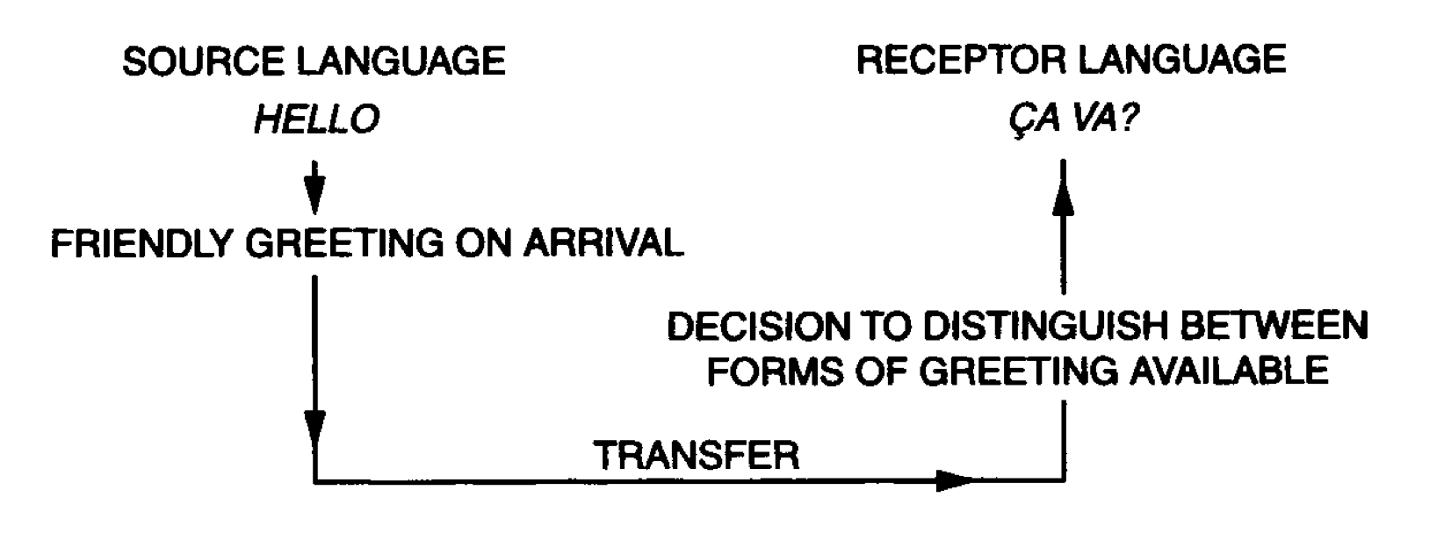
What has happend during the translation process is that the notion of greeting has been isolated and the word hello has been replaced by a phrase carrying the same notion.
In the case of yes the invariant information is affirmation, whilst in the case of hello the invariant is the notion of greeting. But at the same time the translator has had to consider other criteria, e.g. the existence of the oui/si rule in French, the stylistic function of stringing affirmatives, the social context of greeting --whether telephonic or face to face, the class position and status of the speakers and the resultant weight of a colloquial greeting in different societies. All such factors are involved in the translation even of the most apparently straightforward word.

Example 3: The Butter—Burro Translation
For butter in British English carries with it a set of associations of whole-someness, purity and high status (in comparison to margarine, once perceived only as secondrate butter though now marketed also as practical because it does not set hard under refrigeration).
When translating butter into Italian there is a straightforward word-for-word substitution: butter—burro. Both butter and burro describe the product made from milk and marketed as a creamy coloured slab of edible grease for human consumption. And yet within their separate cultural contexts butter and burro cannot be considered as signifying the same. In Italy, burro, normally light coloured and unsalted, is used primarily for cooking, and carries no associations of high status, whilst in Britain butter, most often bright yellow and salted, is used for spreading on bread and less frequently in cooking. Because of the high status of butter, the phrase bread and butter is the accepted usage even where the product used is actually margarine. So there is a distinction both between the objects signified by butter and burro and between the function and value of those objects in their cultural context. The problem of equivalence here involves the utilization and perception of the object in a given context. The butter—burro translation, whilst perfectly adequate on one level, also serves as a reminder of the validity of Sapir's statement that each language represents a separate reality.
 | butter in English | burro in Italian
similarities | describe the product made from milk and marketed as a creamy coloured slab of edible grease for human consumption
differences | Bright yellow and salted ,used for spreading on bread and less frequently in cooking.  whole-someness, purity and high status(in comparison to margarine). | light coloured and unsalted, used primarily for cooking  carries no associations of high status.

Example 4：the Translation of Bon appetit
Let us take a hypothetical dramatic situationas follows.
A family group have been quarrelling bitterly, the unity of the family has collapsed, unforgivable things have been said. But the celebratory dinner to which they have all come is about to be served, and the family sit at the table in silence ready to eat. The plates are filled, everyone sits waiting, the father breaks the silence to wish them all 'Bon appetit' and the meal begins.
Whether the phrase is used mechanically, as part of the daily ritual, whether it is used ironically, sadly or even cruelty is not specified. On a stage, the actor and director would come to a decision about how to interpret the phrase based on their concept of characterization and of the overall meaning and structure of the play. The interpretation would be rendered through voice inflexion. But whatever the interpretation, the significance of the simple utterance cutting into a situation of great tension would remain.
The translator has to take the question of interpretation into account in addition to the problem of selecting a TL phrase which will have a roughly similar meaning. Exact translation is impossible: Good appetite in English used outside a structured sentence is meaningless. Nor is there any English phrase in general use that fulfils the same function as the French. There are, however, a series of phrases that might be applicable in certain situations—the colloquial Dig in or Tuck in, the more formal Do start, or even the ritualistically apologetic I hope you like it, or I hope it's alright.

Conclusion
The translator should:
(l) Accept the untranslatability of the SL phrase in the TL on the linguistic level.
(2) Accept the lack of a similar cultural convention in the TL.
(3) Consider the range of TL phrases available, having regard to the presentation of class, status, age, sex of the speaker, his relationship to the listeners and the context of their meeting in the SL
(4) Consider the significance of the phrase in its particular context—i.e. as a moment of high tension in the dramatic text.
(5) Replace in the TL the invariant core of the SL phrase in its two referential systems (the particular system of the text and the system of culture out of which the text has sprung).

Reference
Susan Bassnett.Translation Studies .Taylor & Francis e-Librar

