中国语言文化 (Chinese Language and Culture)

讲师 (Lecturer): 吴漠汀教授（Professor Martin Woesler）
第十一讲 （The 11th Session）, 第十单元 (Unit 10), 课文 B (Text B),
2020 年 11 月 29 日 (November 29th, 2020)

QIGONG (气功)
Students （学生）: Ngo Thi Minh Huong (吴氏明红）, Rajabov Anushervon（阿努克）

- Brief Introduction about Qigong (气功).
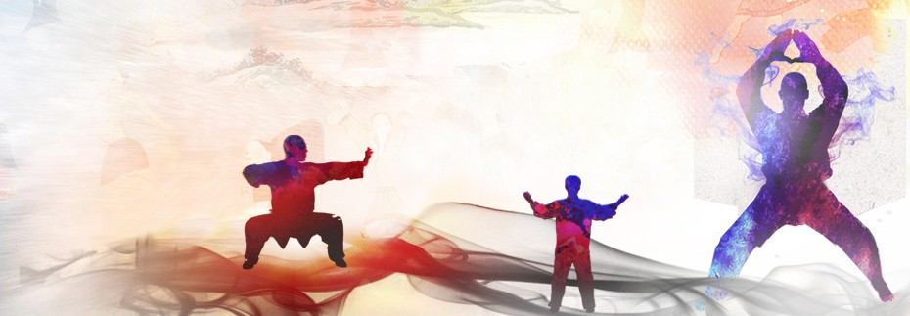
Qigong (/ˈtʃiːˈɡɒŋ/), qi gong, chi kung, or chi gung (simplified Chinese: 气功; traditional Chinese: 氣功; pinyin: qìgōng) is a millennia-old system of coordinated body-posture and movement, breathing, and meditation used for the purposes of health, spirituality, and martial-arts training. With roots in Chinese medicine, philosophy, and martial arts, qigong is traditionally viewed by the Chinese and throughout Asia as a practice to cultivate and balance qi, translated as "life energy".
- Definition.
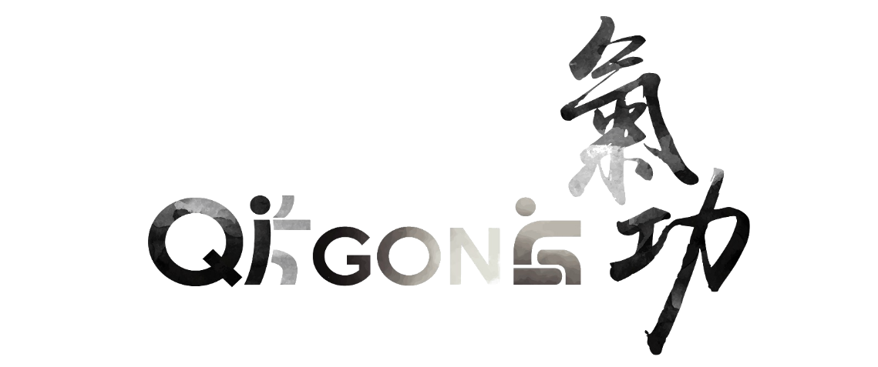
Qigong (气功) can be described as a mind-body-spirit practice that improves one's mental and physical health by integrating posture, movement, breathing technique, self-massage, sound, and focused intent.
Qi (气／氣) primarily means air, gas or breath but is often translated as a metaphysical concept of 'vital energy', referring to a supposed energy circulating through the body; though a more general definition is universal energy, including heat, light, and electromagnetic energy; and definitions often involve breath, air, gas, or the relationship between matter, energy, and spirit. Qi is the central underlying principle in traditional Chinese medicine and martial arts.
Gong (功) is often translated as cultivation or work, and definitions include practice, skill, mastery, merit, achievement, service, result, or accomplishment, and is often used to mean gongfu (kung fu) in the traditional sense of achievement through great effort.
The two words are combined to describe systems to cultivate and balance life energy, especially for health and wellbeing.
The term qigong as currently used was promoted in the late 1940s through the 1950s to refer to a broad range of Chinese self-cultivation exercises, and to emphasize health and scientific approaches, while de-emphasizing spiritual practices, mysticism, and elite lineages.
- History and origins.
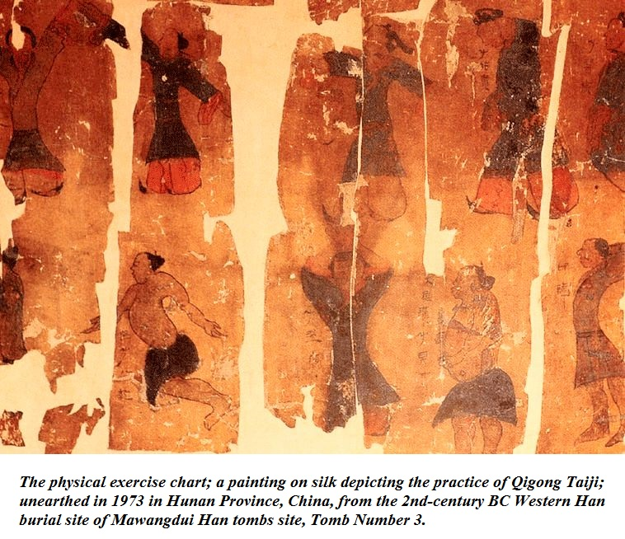
With roots in ancient Chinese culture dating back more than 4,000 years, a wide variety of qigong forms have developed within different segments of Chinese society: in traditional Chinese medicine for preventive and curative functions; in Confucianism to promote longevity and improve moral character; in Daoism and Buddhism as part of meditative practice; and in Chinese martial arts to enhance fighting abilities.
Starting in the late 1940s and the 1950s, the mainland Chinese government tried to integrate disparate qigong approaches into one coherent system, with the intention of establishing a firm scientific basis for qigong practice. In 1949, Liu Guizhen established the name "Qigong" to refer to the system of life preserving practices that he and his associates developed based on Dao yin and other philosophical traditions. This attempt is considered by some sinologists as the start of the modern or scientific interpretation of qigong.
During the Great Leap Forward (1958–1963) and the Cultural Revolution (1966–1976), qigong, along with other traditional Chinese medicine, was under tight control with limited access among the general public, but was encouraged in state-run rehabilitation centers and spread to universities and hospitals.
Popularity of qigong grew rapidly during the Deng and Jiang eras after Mao Zedong's death in 1976 through the 1990s, with estimates of between 60 and 200 million practitioners throughout China. In 1985, the state-run National Qigong Science and Research Organization was established to regulate the nation's qigong denominations.
In 1999, in response to widespread revival of old traditions of spirituality, morality, and mysticism, and perceived challenges to State control, the Chinese government took measures to enforce control of public qigong practice, including shutting down qigong clinics and hospitals, and banning groups such as Zhong Gong and Falun Gong. The Chinese Health Qigong Association, established in 2000, strictly regulates public qigong practice, with limitation of public gatherings, requirement of state approved training and certification of instructors, and restriction of practice to state-approved forms.
Through the forces of migration of the Chinese diaspora, tourism in China, and globalization, the practice of qigong spread from the Chinese community to the world. Today, millions of people around the world practice qigong and believe in the benefits of qigong to varying degrees.
- Types of Qigong.
There are numerous qigong forms. Did you know that over 3,000 types of Qigong exist in the world? There are many forms and styles of Qigong, but they all fit into one of five main categories:
- Medical Qigong to heal self and others
- Martial Qigong for physical prowess
- Spiritual Qigong for enlightenment
- Intellectual Qigong for boosting intelligence and memory
- Vitality Qigong for longevity

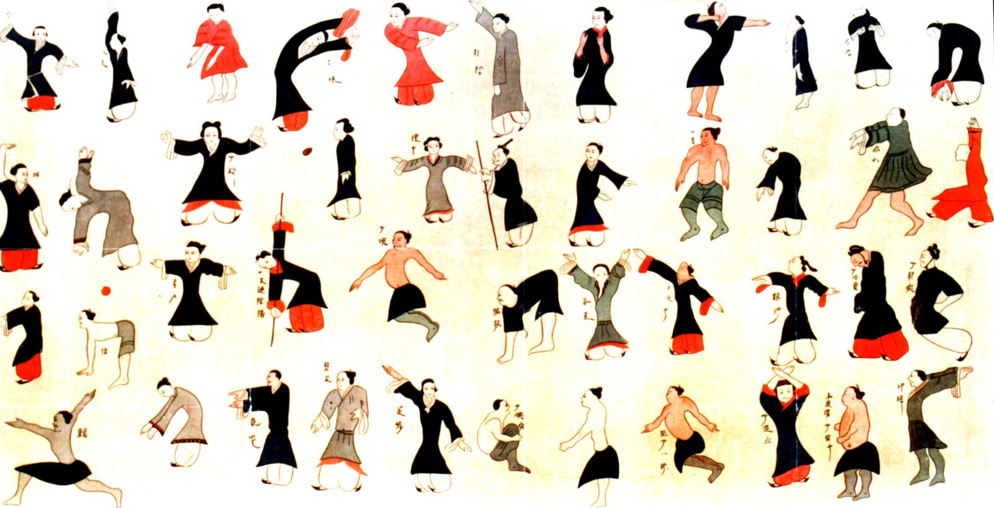

- Medical Qigong (also called Health Qigong)
This is the most popular of the five categories. It is the oldest of the four branches of Traditional Chinese Medicine and the energetic foundation from which acupuncture, herbal medicine, and Chinese massage originated. Thus Qigong shares the foundational theories of Traditional Chinese Medicine and uses similar diagnostic and treatment methods.
There are two types of medical Qigong:
• Self-Healing Qigong, during which individuals practice Qigong exercises to enhance their health, prevent disease, and address illness.
• External Qigong or Qi Emission, during which Qigong practitioners emit Qi with the intention to heal others. In addition to emitting Qi for healing, a good Qigong practitioner usually prescribes specific exercises designed to help regulate Qi.
- Martial Qigong (also called Warrior Qigong)
This type of Qigong focuses on physical prowess. Martial Qigong practitioners can break bricks, bend steel wires, place sharp objects in vulnerable parts of the body without damaging the skin, or sustain physical impact from baseball bats. Martial Qigong practitioners can demonstrate physical feats considered impossible by modern science.
- Spiritual Qigong
This type of qigong uses mantras, mudras (hand positions), sitting meditations, and prayers to pursue enlightenment. These techniques are heavily influenced by Buddhism, Taoism, and Confucianism. Spiritual Qigong teaches discipline and leads to self-awareness, tranquility, and harmony with nature and self.
Spiritual practitioners train their Qi to a much deeper level, working with many internal functions of the body. They practice to obtain control of their body, mind, and spirit, with the goal of escaping from the cycle of reincarnation.
- Intellectual Qigong (also called Scholarly Qigong)
This category covers a lot of ground - from boosting intelligence and memory, to helping with decision-making, to improving your luck. The word “intellectual” isn’t perfect. Sometimes it’s called Scholarly Qigong because it was treasured by the Confucian scholars.
This category incorporates subtle techniques, like Focusing on One, or Positive Visualization. But we can also include dynamic techniques when they are used towards scholarly goals. For example, if we use Nourishing Kidneys to boost the Kidney Qi and thus improve our memory, then that would be Intellectual Qigong.
- Vitality Qigong (also called Longevity Qigong)
These techniques cultivate strength, flexibility, suppleness, and fitness, all of which contribute to overall vitality and thus longevity. Techniques like Three Levels to Earth, Old Monk Takes Off Shoe, and Dancing Fairies are good examples.
- Qigong techniques.
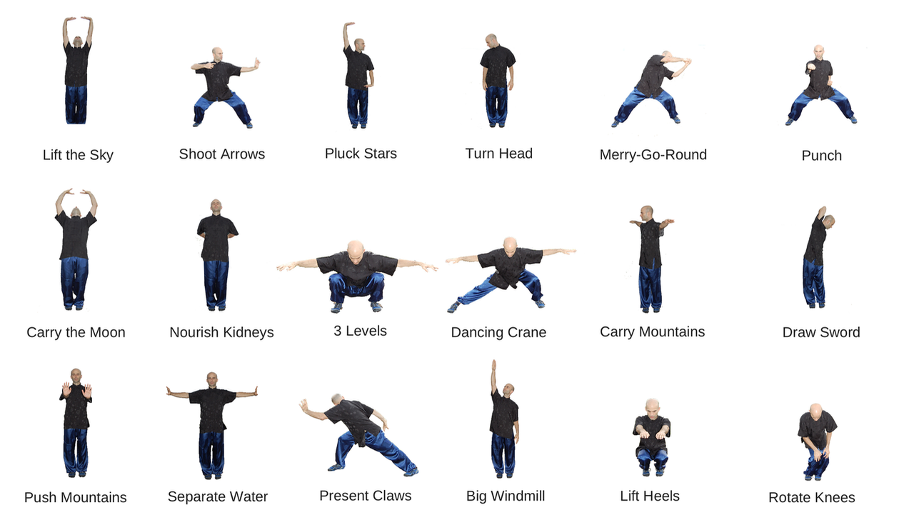
There are two types of Qigong practice:
  - Wai Dan (External Elixir) involves physical movement and concentration
  - Nei Dan (Internal Elixir) involves sitting meditation and guided imagery or visualization
Whether viewed from the perspective of exercise, health, philosophy, or martial arts training, several main principles emerge concerning the practice of qigong:
- Intentional movement: careful, flowing balanced style
- Rhythmic breathing: slow, deep, coordinated with fluid movement
- Awareness: calm, focused meditative state
- Visualization: of qi flow, philosophical tenets, aesthetics
- Chanting/Sound: use of sound as a focal point
Additional principles:
- Softness: soft gaze, expressionless face
- Solid Stance: firm footing, erect spine
- Relaxation: relaxed muscles, slightly bent joints
- Balance and Counterbalance: motion over the center of gravity
Advanced goals:
- Equanimity: more fluid, more relaxed
- Tranquility: empty mind, high awareness
- Stillness: smaller and smaller movements, eventually to complete stillness
The most advanced practice is generally considered to be with little or no motion.

- Contemporary qigong.
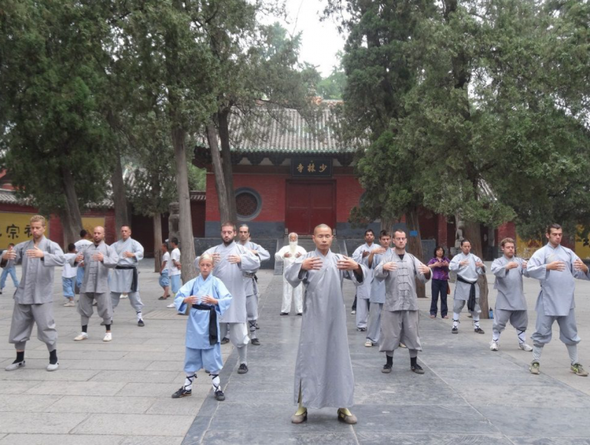

Contemporary qigong blends diverse and sometimes disparate traditions, in particular the Daoist meditative practice of "internal alchemy" (Neidan 內丹術), the ancient meditative practices of "circulating qi" (Xing qi 行氣) and "standing meditation" (Zhan zhuang 站桩), and the slow gymnastic breathing exercise of "guiding and pulling" (Dao yin 導引). Traditionally, qigong was taught by master to students through training and oral transmission, with an emphasis on meditative practice by scholars and gymnastic or dynamic practice by the working masses.
In contemporary China, the emphasis of qigong practice has shifted away from traditional philosophy, spiritual attainment, and folklore, and increasingly to health benefits, traditional medicine and martial arts applications, and a scientific perspective. Qigong is now practiced by millions worldwide, primarily for its health benefits, though many practitioners have also adopted traditional philosophical, medical, or martial arts perspectives, and even use the long history of qigong as evidence of its effectiveness.
Qigong has been recognized as a "standard medical technique" in China since 1989, and is sometimes included in the medical curriculum of major universities in China.

- Benefits of Qigong.
Qigong opens the flow of energy in meridians used in acupuncture and Chinese medicine. It enhances our ability to feel the Life Force underlying the physical world and to deepen our communication with it.
Physically, slow gentle qigong movements warm tendons, ligaments, and muscles; tonify vital organs and connective tissue; and promote circulation of body fluids (blood, synovial, lymph). Thousands of studies have shown qigong effective in helping to heal life challenges ranging from high blood pressure and chronic illness to emotional frustration, mental stress, and spiritual crisis.

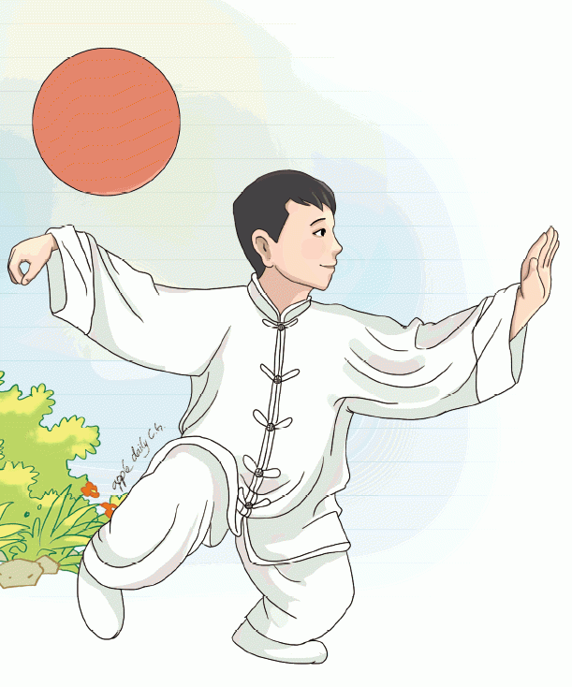

References:
https://en.wikipedia.org/wiki/Qigong
https://www.nqa.org/what-is-qigong-
https://www.takingcharge.csh.umn.edu/qigong
https://qigong.com/what-are-the-different-types-of-qigong/
https://flowingzen.com/18271/history-of-qigong-the-5-categories-of-qi-cultivation/

