Cuju
Liu Yi, English Interpreting, 202370081605
Abstract: Cuju, an ancient Chinese sport, is widely regarded as an early form of modern football. This paper discusses the origins and development of cuju, its rules and formats, and its historical and cultural significance. Furthermore, It also delves into the connection between cuju and modern football, as well as its status as an intangible cultural heritage. Through this analysis, the study aims to deepen understanding of cuju as a traditional sport and highlight its enduring cultural importance.
Cuju, a sport with deep cultural and historical significance, dates back to the Warring States period (c. 475–221 BCE) and later became a popular form of entertainment during the Han (202 BCE–9 CE, 25–220), Tang (618–907), and Song (960–1279) dynasties. Recognized as one of the earliest forms of football globally, cuju showcased the creativity of ancient Chinese sports and emerged as a significant symbol of traditional Chinese culture. In 2004, FIFA acknowledged cuju as the origin of modern football, and in 2006, it was listed as a National Intangible Cultural Heritage in China, underscoring its historical and cultural importance.
1. Origins and Development of Cuju
Historical studies of global sports suggest that foot-based ball games were played in various ancient civilizations, including Egypt, Rome, and Arabia (Yan, 1990). However, the most convincing and well-documented origin of football traces back to China. Evidence shows that ancient Chinese cuju served as the precursor to modern football, and the widely recognized statement that “the origin of world football lies in cuju from Linzi, Zibo, China” supports this claim (Zhang YJ, 2007). “Cu” refers to kicking with the foot, while “ju” refers to a leather ball, making cuju literally “kicking the ball”.
Cuju traces its origins back to the Shang Dynasty (c. 1600–1050 BCE), as evidenced by references in oracle bone inscriptions (Zhang MJ, 2015). By the Warring States period, it had evolved into a popular form of folk entertainment. Strategies of the Warring States records that as early as 2,300 years ago, the people of Qi played cuju as a recreational game.
By the Han Dynasty, cuju had become more refined, with advancements in ball-making techniques, such as filling the ball with hair instead of simple materials. Initially, it was used in military training to enhance soldiers’ agility and strength, improving their combat readiness. However, as society became more stable, cuju gradually transitioned into a widely enjoyed recreational activity among the people.
Guided by the folk culture and imperial authority, cuju reached its height of popularity during the Tang and Song Dynasties (Ren, 2013), becoming not only a common pastime among the people but also a major activity of palace entertainment. Emperor Zhao Kuangyin (960-976), the founder of the Song Dynasty, and his brother Zhao Guangyi (939–997) were passionate cuju players. This enthusiasm is vividly captured in the Yuan Dynasty(1279–1368) artist Qian Xuan’s (1235–1305) painting Emperor Taizu of the Song Dynasty Playing Cuju, which portrays Zhao Kuangyin and his ministers engaging in the game. Emperor Huizong of Song (1082–1135) was also a devoted fan of cuju. According to Water Margin, Gao Qiu (c.1076–1126), earned Emperor Huizong’s favor thanks to his exceptional cuju skills.
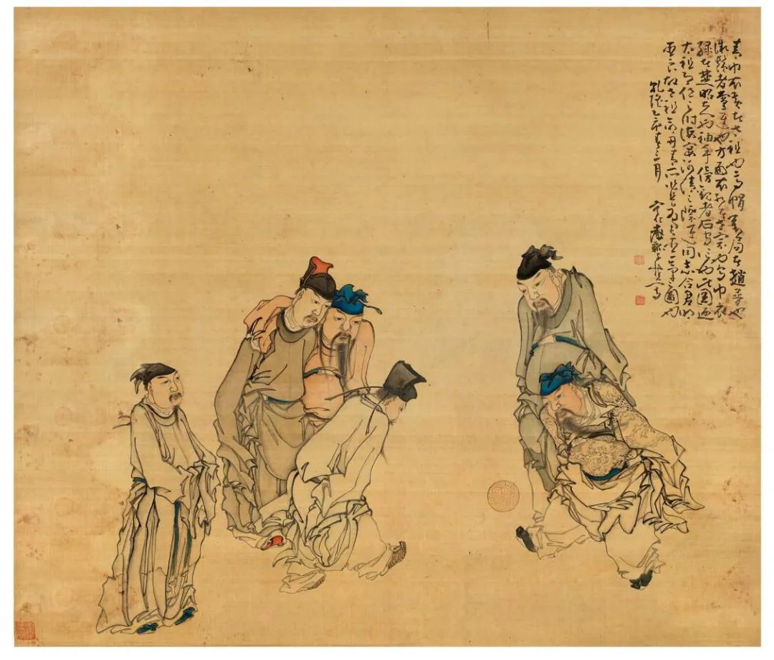
Figure 1: Emperor Taizu of the Song Dynasty Playing Cuju
2. Rules and Formats of Cuju
Cuju gained popularity among both soldiers and civilians, attracting participants of all ages, including children and women. During the Song Dynasty, the sport underwent significant professionalization, with specialized cuju troupes performing at palace banquets. While some people earned their livelihood by showcasing their cuju skills, others engaged in the sport just for fun. The professional clubs and the standardized rules further enhanced the promotion of cuju, solidifying its place in society (Fu, 2012).
Although cuju shares some similarities with modern football, it differs significantly in its rules and formats. Modern football focuses on scoring goals by kicking the ball into the opponent’s net on a large field with well-defined rules. In contrast, cuju prioritizes ball control and technical skill, requiring players to keep the ball off the ground and often target higher goals. One unique format, “Through the Hole”, involved kicking the ball through a small opening, showcasing technical precision. Cuju also featured movements such as using the shoulders and head to control the ball, with some actions like the modern bicycle kick, adding both entertainment value and visual appeal. In addition, the development of relatively comprehensive game rules also significantly enhanced the competitiveness of cuju activities (Liu, 2018).
In the Song Dynasty, cuju was played in two main formats. The first, known as Baida (To Strike), did not involve goals or field restrictions. It emphasized ball control techniques and was mainly played for entertainment. The second format, Single Goal, featured a shared goal used by both teams. Players took turns shooting, and the team with the most goals won. Teams were differentiated by their jerseys, with one wearing red (Red Team) and the other gray (Gray Team).
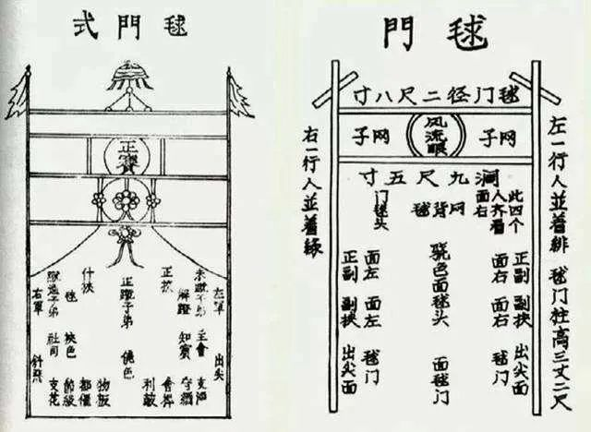
Figure 2: Cuju Goal
3. Cultural Value of Cuju
Cuju, an important ancient Chinese sport, carried both competitive and profound cultural value. It held an integral role in ancient society, being widely used in celebrations, diplomatic events, and palace banquets (Wan, 2017). From folk festivals to royal performances, cuju fostered social interactions and offered a source of entertainment.
Cuju demonstrated a notable level of gender equality in ancient society, as women actively took part in the sport. This inclusivity is evident in Song Dynasty bronze mirrors, which depict scenes of men and women playing cuju together.
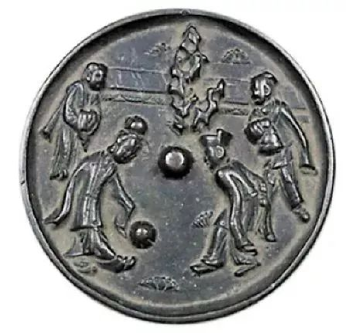
Figure 3: Bronze Mirror with Figures Playing Cuju
Cuju, as an integral aspect of Chinese traditional culture, represents the nation’s spiritual aspirations and cultural identity. It stands as a symbol of unity and heritage, fostering a sense of cultural connection and belonging. Recognized for its significance, cuju was designated a National Intangible Cultural Heritage in 2006, further underscoring its importance in preserving Chinese cultural traditions.
4. Connection Between Cuju and Modern Football
Cuju not only represents ancient Chinese cultural values but also shares a connection with modern football in terms of its origins and global cultural influence. Although the two differ significantly in rules and formats, they share commonalities, highlighting a connected legacy.
Firstly, in 2004, FIFA officially recognized cuju as the origin of modern football. This acknowledgment reaffirmed the historical significance of traditional Chinese sports and positioned cuju as a cultural bridge between the ancient and modern worlds, as well as between the East and the West.
Secondly, Cuju and modern football share a universal appeal, drawing passionate fans and showcasing exceptional players. Historical figures such as Gao Qiu, renowned for his cuju expertise, mirror modern football icons like Klose and Müller, who captivate global fans with their remarkable skills.
Finally, as an intangible cultural heritage of China, cuju gradually faded from the mainstream due to waning support from rulers, yet it never completely vanished. Its cultural significance continues to leave a lasting impact on modern society (Deng, 2012). The historical legacy and cultural identity of cuju provide the opportunity for revitalizing Chinese football while also offering valuable Chinese insights to enrich global sports and cultural exchanges.
5. Inspiration from Cuju for Modern Football
Over time, the popularity of cuju gradually declined not only by social changes and the decreasing support from rulers but also by the commercialization trend that emerged during the late Song Dynasty. Amid the economic prosperity of this era, cuju began to adopt commercial elements, enhancing its entertainment and visual appeal to attract audiences. However, while these changes brought market-oriented features to the sport, they also undermined its original purpose as a sport for all, eventually leading to its decline in mainstream society. Despite this, cuju culture did not vanish entirely; its spirit and essence have endured through literature, art, and folk traditions, leaving behind a rich cultural heritage for future generations.
Today, despite the challenges faced by China national football team in international competitions, the passion of football fans remains unwavering. By embracing and revitalizing the cultural heritage of cuju, Chinese football can draw on the historical wisdom of this ancient sport to enhance its appeal, entertainment value, and societal engagement, paving the way for a renewed presence on the global stage. While initiatives like campus football are a promising start, achieving broader social engagement in football requires additional efforts to develop youth, corporate, and community football programs. These initiatives will help build a robust social foundation and establish a sustainable market-oriented mechanism (Wan, 2017).
Terms and Expressions
Cuju 蹴鞠
Emperor Taizu of the Song Dynasty Playing Cuju 《宋太祖蹴鞠图》
Through the Hole 风流眼
Bicycle Kick 倒挂金钩
To Strike 白打
Single Goal 单球门
Goal 球门
Questions & Answers
Q1: What is cuju, and why is it significant?
A1: Cuju is an ancient Chinese sport considered the precursor to modern football. It represents a rich Chinese sports cultural and historical heritage.
Q2: When was cuju officially recognized by FIFA?
A2: In 2004, FIFA officially recognized cuju as the origin of modern football.
Q3: When was cuju included in China’s National Intangible Cultural Heritage List?
A3: In 2006, cuju was included in China’s National Intangible Cultural Heritage List.
Q4: What are the two main formats of cuju?
A4: The two main formats of cuju are To Strike (no goal, focusing on ball control) and Single Goal (shared goal, score-based competition).
Q5: Why did cuju decline in popularity?
A5: Cuju declined due to decreased support from rulers and increasing commercialization during the late Song Dynasty.
Q6: How can cuju contribute to modern football?
A6: By preserving and innovating cuju, it can enhance the entertainment, appeal, and social engagement of modern football.
Conclusion
Learning more about cuju goes beyond revisiting a traditional sport; it is a powerful expression of cultural confidence. Preserving and innovating cuju bridges the past and present, enriching Chinese football with cultural strength while fostering greater exchange on the global sports stage.
References
- Deng Yong. On the Evolution and Decline of Ancient Chinese Cuju [J]. Lantai World, 2012, (33): 24-25.
- Fu Qiang. Analysis of Historical and Cultural Reasons for the Prosperity of Cuju in the Song Dynasty [J]. Lantai World, 2012, (30): 28-29.
- Hui-yi R E N. A study of Cuju culture in the Song dynasty[J]. Journal of Physical Education/Tiyu Xuekan, 2013, 20(5).
- Liu X, Zhang Y, Ma X. Historical Study on the Relation between Ancient Chinese Cuju and Modern Football[C]//2018 4th International Conference on Innovative Development of E-commerce and Logistics (ICIDEL 2018). http://166.62. 7.
- Wan Xia, Xing Shuying. Inspiration of Cuju in the Song Dynasty for Modern Chinese Football [J]. Sports Culture Guide, 2017, (08): 174-178.
- Yan Shaolu. History of Sports [M]. People’s Sports Press, 1990.
- Zhang Mengjie. Evolution of Ancient Chinese Cuju [J]. Sports Culture Guide, 2015, (03): 162-164+194.
- Zhang Yongjun, Zhang Shujun, Wang Jinglong. Research on the Origin of World Football—The Development and Spread of Cuju in Linzi [J]. China Sports Science and Technology, 2007, (04): 36-42+81.
AI Statement
I hereby guarantee that I have not used the help of AI to write my final paper in this course.

