Principles of Translation
Wu Yinghong 吴映红 202120081530
- Beginning
The so-called principles of translation are actually the two sides of the
same thing. The principles of translation lays emphasis on the translator, who should follow them while translating.
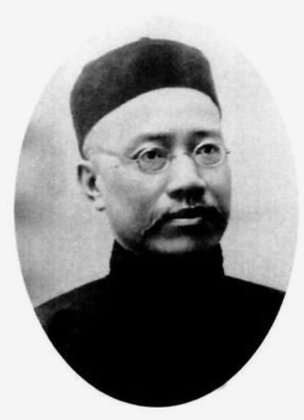

Yan Fu’s "three-character guide", which was first proposed in 1898, would evoke controversy, namely, the principle of "信、达、雅"

In the past decades Mr. Yan's principle of translation has been generally regarded as a plumb-line for measuring the professional level of translation and a goal for translators to strive after.

However, in the application of this principle, people have come to find some limitations to the three characters and put forward a variety of new standards instead.

2.Development
(1)The first group: maintains the original three characters, and in the meantime, adds some new concepts to the character "雅". According to them, "雅" means far more than the English word "elegance". Apart from the traditional interpretation, it also means classicism, the adherence to the original style and flavor.
faithfulness, expressiveness and elegance is proposed by Yan Fu.
For example
1) Beauty is a gift of God. —Aristotle
美是上帝赋予的礼物 literal translation
美者，天赋也。
2)中华儿女多奇志，不爱红妆爱武装。—Mao Zedong
The Chinese people are so ambitious that they don't love red makeup and armed. literal translation
Chinese people prefer to face the powder rather than powder the face.

(2)The second group: argues that the word "雅" is out of place in translation. While adopting the first two characters of Mr. Yan Fu's principle, it discards the character "雅" and tries to find some other new criteria instead. Noticeably, there are revisions such as "信、达、切 " (faithfulness, expressiveness and closeness) and so on.

Notes: faithfulness, expressiveness and closeness is proposed by Liu ChongDe. Closeness means to conform to the style of the original text.
For example
- “Don't have a cow! I'll pay for the damages.
不要母牛!我会赔偿其损失的 literal translation
别大惊小怪!我会赔偿其损失的。
2) “The comedian got the bird, because of his bad performance.”
那喜剧演员因表演拙劣得了一只鸟 literal translation
那喜剧演员因表演拙劣让人喝了倒彩
3) “你这该死的家伙”
“My god!”
“Damn it!”

(3)The third group: by casting away the three-word guide, propose some new principles or criteria of translation of their own. Of the various popular theories two of them are most influential: spiritual conformity (神似 ) and sublimated adaptation ( 化境 ).

spiritual conformity was proposed by Fu Lei emphasizes the reproduction of the spirit or the flavor of the original.
For example:
1)“Pangloss enseigait la metaphysico-thelologo-cosmolo-nigologie, il prouvait admirablement qu’il n’y apoint defect sans cause”
“邦葛罗斯教的是一种包罗玄学、神学、宇宙学的学问。他很巧妙地证明天下事有果必有因, ……

sublimated adaptation was advocated by Qian Zhongshu, focuses on the translator's smooth and idiomatic Chinese version for the sake of the Chinese reader.
For example:
1)“Whom every thing becomes, to chide, to laugh, to weep; whose every passion fully strives to make itself, fin these, fair and admired!”
嗔骂, 嬉笑, 嘀泣, 各态咸宜, 七情能生百媚。

The “Spirit Likeness ”by Fu Lei is the perfect conversion from traditional Chinese painting theory to translation theory, which aims at “translating to be spiritual likeness with the source text”; while Qian Zhongshu's “Sublimation Theory” is to “keep artistic conception skillfully”. By virtue of their profound cultural quality and the deep understanding on western culture, both great masters have impressed the Chinese translation course with their translation masterpieces.

3.Summary
Despite the variety of opinions, two criteria are almost unanimously accepted, namely, the criterion of faithfulness/accuracy（忠实、准确) and that of smoothness (流畅). We may also take these two criteria as the principles of translation in general. By faithfulness/ accuracy, we mean to be faithful not only to the original contents, to the original meaning and views, but also to the original form and style. By smoothness, we mean not only easy and readable rendering, but also idiomatic expression in the target language, free from stiff formula and mechanical copying from dictionaries.

4.reference
[1]王禹霏.浅谈“神似”与“化境”[J].牡丹江教育学院学报,2016(05):7-8.
[2]丁轶青.翻译中的“信达雅”与“信达切”[J].校园英语,2020(51):245-246.
[3]谭晓丽.“信、达、切”在文学翻译中的运用[J].衡阳师范学院学报(社会科学),2003(05):117-119.
[4]郑延国.钱锺书说“信达雅”[J].书屋,2021(06):13-15.
[5]李丹丹.从“信达雅”角度看傅译《老实人》[J].文学教育(下),2021(04):11-13.
[6]王密卿,赵长江.“神似”与“化境”何为文学翻译的最高标准考辨[J].河北大学学报(哲学社会科学版),2012,37(04):148-152.

