Early attempts at systematic translation theory

Background
In the seventeenth century, apart from the Bible, translation into English was almost exclusively confined to verse renderings of Greek and Latin Classics, some of which were extremely free. Abraham Cowley’s approach is to counter the inevitable loss of beauty in translation by using our wit or invention to create new beauty. He also put forward the term imitation in order to achieve the spirit of the ST(source text) to be best reproduced. Such a very free approach to translation produced a stress reaction, notably from three famous translators, Etienne Dolet, John Dryden and Alexander Fraser Tytler.
- Three Representatives
  - Etienne Dolet
Etienne Dolet is the father of French translation theory. He is also the first person to put forward systematic translation theory in modern European history. In his 1540 manuscript La manière de bien traduire d’une langue en aultre he set out five principles in order of importance as follows:
- The translator must perfectly understand the sense and material of the original author, although he should feel free to clarify obscurities.
- The translator should have a perfect knowledge of both SL and TL, so as to lessen the majesty of the language.
- The translator should avoid word-for-word renderings.
- The translator should avoid Latinate and unusual forms.
- The translator should assemble and liaise words eloquently to avoid clumsiness.
Here again, the concern is to reproduce the sense and to avoid word-for-word
translation.

  - John Dryden
Other early writers on translation also began to state their principles in a similarly prescriptive fashion. One of the first had been John Dryden, who is the founder of English classicism and a great translator. In the preface to his translation of Ovid’s Epistles in 1680, Dryden reduces all translation to three categories:
- “metaphrase” : Word by word and line by line translation, which corresponds to literal translation.
- “paraphrase” : The author is kept in view by the translator but his words are not so strictly followed as his sense. It corresponds to sense-for-sense translation.
- “imitation” ：Forsaking both words and sense. It corresponds to Cowley’s very free translation and more or less adaptation
Dryden rejects imitation, where the translator uses the ST ‘as a pattern to write as he supposes that author would have done, had he lived in our age and in our country’ (ibid.). Imitation, in Dryden’s view, allows the translator to become more visible, but does ‘the greatest wrong . . . to the memory and reputation of the dead’. He thus prefers paraphrase, advising that metaphrase and imitation be avoided. In general, Dryden and others writing on translation at the time are very prescriptive, setting out what in their opinion has to be done in order for successful translation to take place.

  - Alexander Fraser Tytler
In English, he is the first systematic study of translation after Dryden. His
famous translation work is ‘Essay on the principles of translation’. Tytler defines a ‘good translation’ as being oriented towards the target language reader. Tytler has three general ‘laws’ or ‘rules’.
- The translation should give a complete transcript of the ideas of the original work.
- The style and manner of writing should be of the same character with that of the original.
- The translation should have all the ease of the original composition.
Tytler’s first law ties in with Dolet’s first two principles in that it refers to the translator having a ‘perfect knowledge’ of the original, being competent in the subject and giving ‘a faithful transfusion of the sense and meaning’ of the author. Tytler’s second law, like Dolet’s fifth principle, deals with the style of the author and involves the translator’s both identifying ‘the true character’ of this style and having the ability and ‘correct taste’ to recreate it in the TL. The third law talks of having ‘all the ease of composition’ of the ST. Tytler regards this as the most difficult task and likens it, in a traditional metaphor, to an artist producing a copy of a painting. Tytler ranks his three laws in order of comparative importance. For instance, the discussion of translation ‘loss’ and ‘gain’, which continues even to the present, is in some ways presaged by Tytler’s suggestion that the rank order of the laws should be a means of determining decisions when a ‘sacrifice’ has to be made.

  - Similarities and differences
- similarities:
Their translation theories were prescriptive. They had set out what has to be done for successful translation;
Their translation theories were based on experience rather than on the language itself.
- differences :
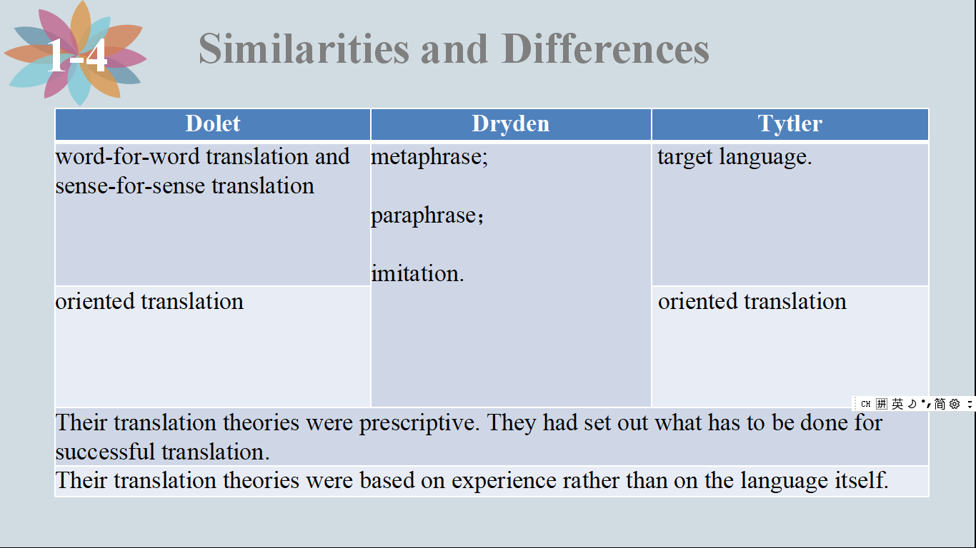
- Conclusion
Writing of the three translators remains full of the language of their time: the ‘genius’, or special characteristics, of the ST author and language, 12 the ‘force’ and ‘spirit’ of the original, the need to ‘perfectly comprehend’ the sense of the original, and the ‘art’ of translation. In general, as we known, Dolet, Dryden and Tytle marked an important step forward in translation theory.

- Reference
[1] Bell，Roger T. 2001. Translation and translating：theory and practice[M]. Beijing：Beijing Foreign Language Teaching and Research Press.
[2] Munday, Jeremy. 2001. Introducing translation studies: early attempts at systematic translation theory[M]. London：Routledge.
[3] 谭载喜． 西方翻译理论[M]. 北京:商务印书馆. 2004: 70-71.
[4] 别芳芳，黄勤. 多雷和泰特勒翻译原则之比较研究[J]. 外语教2008.(3)15.
[5] Jeremy Munday. 翻译学导论 理论与应用[M]. 李德凤, 等, 译. 北京:
外语教学与研究出版社，2014.
[6] 仇慧芳. 从德莱顿“翻译三分法”谈诗译者的素质[J]. 北方文学，2019（8）
23.

