Women in Ancient China
Place of women
The women in ancient Chinese culture lived according to the rules set by Confucius in his analects. According to Confucius, women were not equal to men and were not worthy to have literary and education. For almost two thousand years, the life of the Chinese woman was unbearable. During the years of growing up, a Chinese woman had to listen to her father and other male members in the family. A woman in ancient China was not given a name; instead she was called "daughter no1", "daughter no2" and so on.
Right of women
Women’s rights in ancient China were virtually non-existent. Females were suppressed because they were deemed less useful or valuable than males. Essentially, this viewpoint was not created in the space of a few years. It is really part of China's ancient social foundations.
Feet binding
Ancient Chinese women were socially pressured, even forced, to bind their feet because men believed that it was more attractive. Not only does this reason seem preposterous, but the binding of the feet was also socially important. A daughter whose feet have been bound since the age of two or three is more likely to marry a wealthy man (who would have also believed in this cultural phenomenon). The woman did not have a choice as to whether or not she wanted her feet bound. If her family tells her to do it, she has to do it in fear of shaming her family. Feet binding only became illegal in China in the early 1900s. 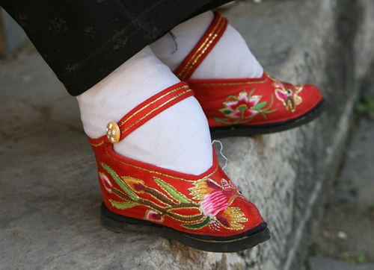

Academics
Women were also not allowed to learn academics as boys were allowed; this is an excellent parallel to the western hemisphere's early treatment of females: they were not allowed to learn academically but instead were forced to stay at home to learn domestic duties such as weaving, taking care of the children, cleaning, etc.
Concubine
Ancient China also protected the male from acquiring a sort of bad reputation regarding marriage. For instance, men could marry and still keep concubines. In fact, most of the time men were encouraged to sleep around because this kept him happy. Of course, women did not have a say in any of this; most of the time, they took the pain and lived with it, even while watching their husbands have children with various other women.
While today divorce is quite common, ancient China prohibited divorce in many cases, especially if women were the first to ask about obtaining one. It was deemed shameful for her and her family. If a woman was divorced by her husband, she was considered to have brought shame upon the family and herself, and these women tend to live secluded lives, lacking friends and even family.

