The Development of Machine Translation
吴漠汀教授（Martin Woesler）Session 4, 2020 年 10 月 19 日

- Introduction to Machine Translation
The basic principle of MT, in short words, is to translate the source language into the target language. Here is an example. The Chinese sentence should be translated into an English one.
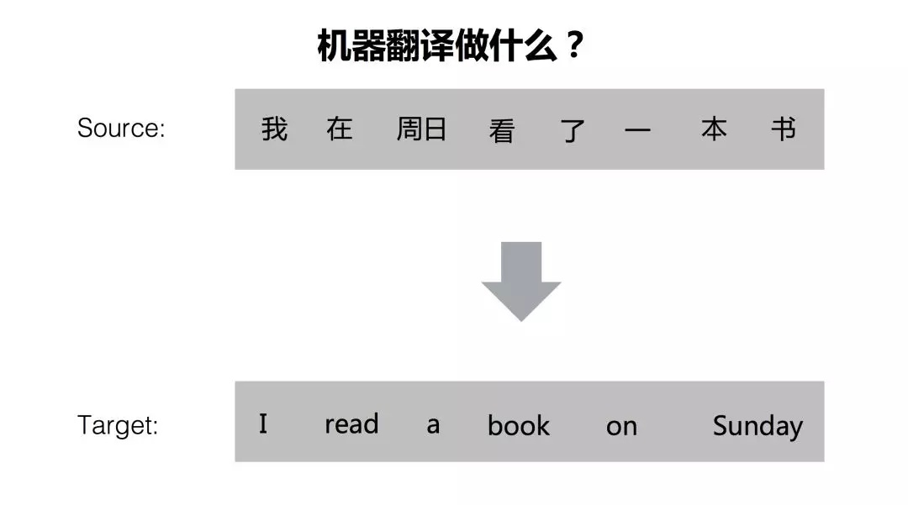
In this conversion process, MT faces two challenges. One is the challenge of choosing proper words, the other is the challenge of arranging the order of the chosen words.
For the choice of words, there are a lot of problems because of polysemy. For example, “看” in the source sentence can be translated into “ see”, “watch”, “read” and “see” in English. If the object “书” has not been considered, these words are all correct. So for the MT system, the point is to know the object of “看” is “书”.
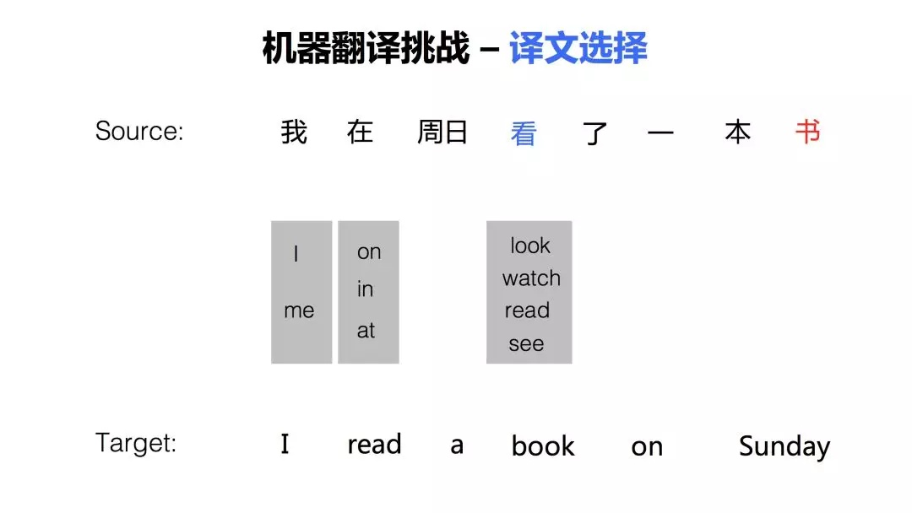
The arrangement of order is also one challenge. For different language systems, it is normal to see the difference in the order of sentence components. In this example, the Chinese put the temporal adverbial “在周日” at the beginning of the sentence. But in English, “on Sunday” is a phrase that needs to be put at the end. When sentences become longer, the adjustment of word order becomes more complicated for the MT system.
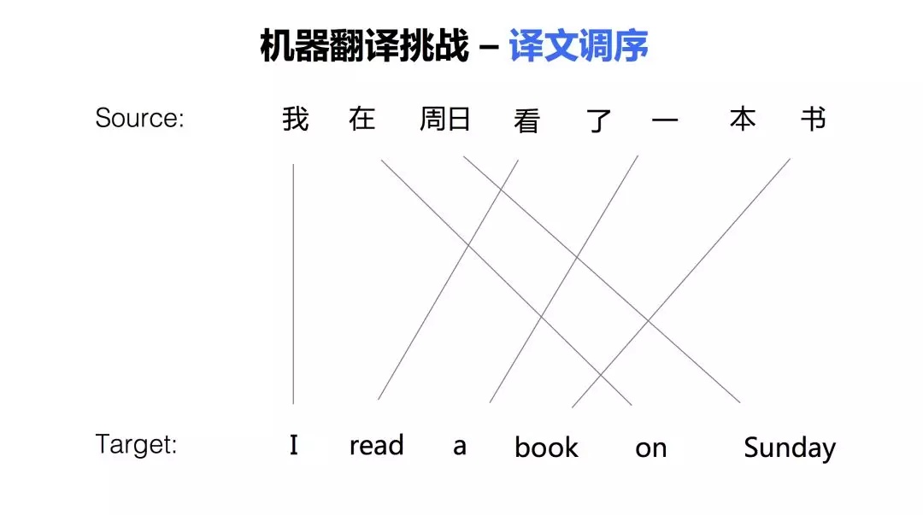

- Different Stages of Machine Translation
The stages of MT development can be divided into the following stages: proposal (1933-1949); early stage (1949-1964); setback (1964-1975); recovery (1975-1989); development (1993-2006); prosperity (2006-present). Here is a graph of MT developments.
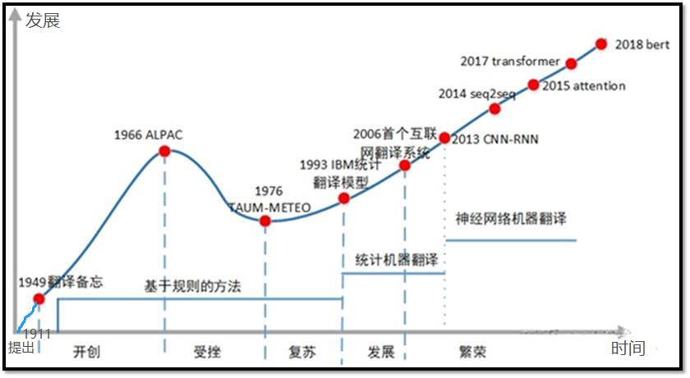
2.1. Proposal (1933-1949)
The history of MT research can be traced back to the 1930s. In 1933, French scientist G.B. Artsouni put forward the idea of using machines for translation. In 1946, the world's first modern electronic computer, ENIAC, was born. Soon afterward, American scientist Warren Weaver, a pioneer in information theory, proposed the idea of using computers for automatic language translation in 1947. In 1949, he published the famous memorandum, formally proposing the idea of MT.
2.2. Early-stage (1949-1964)
In 1954, Georgetown University, in collaboration with IBM, used the IBM-701 computer to complete the English-Russian MT experiment. For the first time in history, the IBM-701 computer automatically translated 60 Russian sentences into English. But no one mentions that the samples obtained from these translations have been carefully selected and tested to eliminate ambiguity. During this period, the United States and the Soviet Union invested a lot of money in MT for military needs. It focuses on the language pair translation between English and Russian. The main objects of translation are scientific and technical documents, such as articles in scientific journals. A rough translation is enough to understand the basic content of the article. Due to economic needs, European countries have also given considerable attention. MT was booming during this period.
2.3. Setback (1964-1975)
However, just as everything is proceeding in an orderly manner, MT research, which is still in its infancy, suffers a blow. In 1966, the Automatic Language Processing Advisory Committee published a report called Language and Machines (ALPAC-Report) in November 1966. The report completely denied the feasibility of MT and declared that "in the near or foreseeable future, there is no hope for the development of a practical MT system." Funding support for MT projects is recommended to stop. Affected by this report, various MT projects have dropped sharply, and MT research has experienced an unprecedented depression.
2.4. Recovery (1975-1989)
In the mid and late 1970s, with the development of computer technology and linguistics and the demand for social information services, MT began to recover and flourish. The industry has developed a variety of translation systems, such as Weinder, URPOTRAA, TAUM-METEO, etc. Among them, the TAUM-METEO system, which was jointly developed by the University of Montreal in Canada and the Translation Bureau of the Federal Government of Canada in 1976, is a milestone in the history of MT development, marking MT from recovery to prosperity.
2.5. Development (1993-2006)
This period is mainly about statistical machine translation (SMT). A translation model based on word alignment was proposed by IBM's Brown and Della Pietra in 1993. It marked the birth of modern statistical MT methods.
In 2003, Franz Och proposed a log-linear model and its weight training method. This article proposed a phrase-based translation model and a minimum error rate training method. The corresponding two articles Statistical phrase-based translation and Minimum error rate training in statistical MT marked the real rise of the SMT.
2.6. Prosperity (2006-Now)
As Franz Och left Google, deep learning technology began to rise and brought the birth of neural machine translation (NMT). NMT is still a translation technology based on text corpus, but uses a completely different model. In NMT, words are mapped to vectors in a high-dimensional vector space and mapped to the target language through neural networks. This method solves many problems of the traditional method, such as the length limitation of the ordering model, and its fluency is greatly improved compared with the previous method. In 2016, companies such as Baidu and Google successfully upgraded their online MT systems to neural network MT systems. Because its quality is generally considered to have crossed the practical threshold of many applications, it also triggered the second wave of MT. This is the era we are now in. Neural network MT has finally crossed the practical threshold in many specific application fields.

- The Development of MT Methods
Generally, the development of MT methods is roughly going through three stages: rule-based methods, statistical machine translation and neural machine translation.
  - Rule-based Translation
The core of rule-based translation is the rule. Where do the rules come from? Translating knowledge comes from human experts, so human linguists make rules. For example, the specific word is translated into the corresponding word, the specific component is translated into another component, and the positions of these words are expressed by the rules.
The advantage of this way is obvious. With the knowledge of experts, it has high accuracy. At the same time, its cost is very high. For example, to develop a translation system for Chinese and English, you need to find a linguist who can speak both Chinese and English. To develop a translation system for another language, it is necessary to find a linguist who understands another language. Therefore, the rule-based system development cycle is very long. Besides, there is also the problem of conflict between rules. As the number of rules increases, the rules restrict and influence each other. Sometimes a rule written to solve a problem may cause the translation of other sentences and bring a series of problems. To solve this series of problems, more rules have to be introduced, forming a vicious circle.
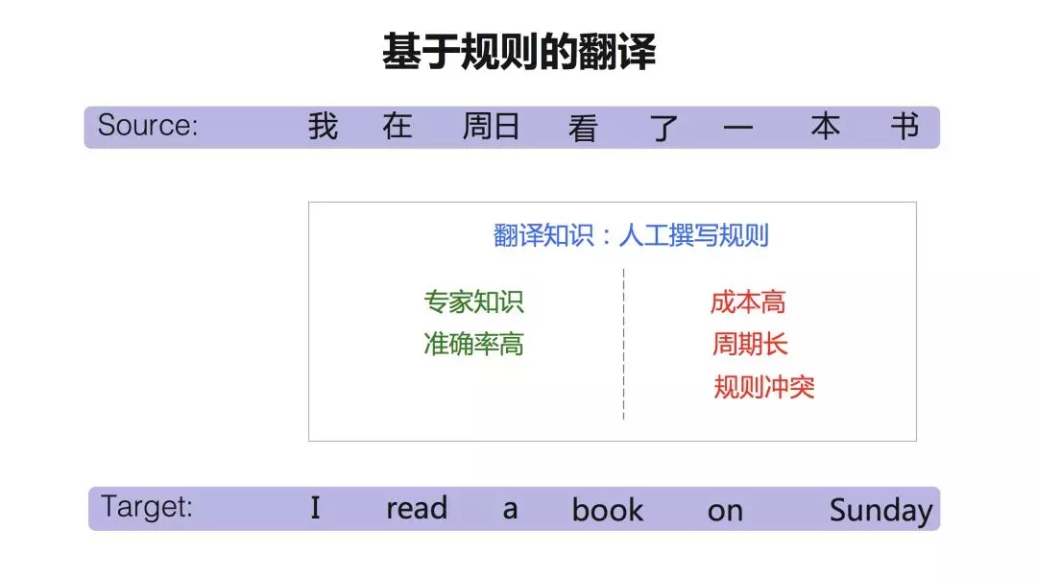
3.2. Statistical Machine Translation
The statistical machine translation system performs mathematical modeling of machine translation. Its cost is very low because this method is language independent. Once this model is established, it can be applied to all languages. Statistical machine translation is a corpus-based method, so if the amount of data is relatively small, it will face a data-sparse problem. At the same time, there is another problem. Its translation knowledge comes from automatic training of big data, so how to add expert knowledge? This is also a relatively big challenge faced by the current machine translation methods.
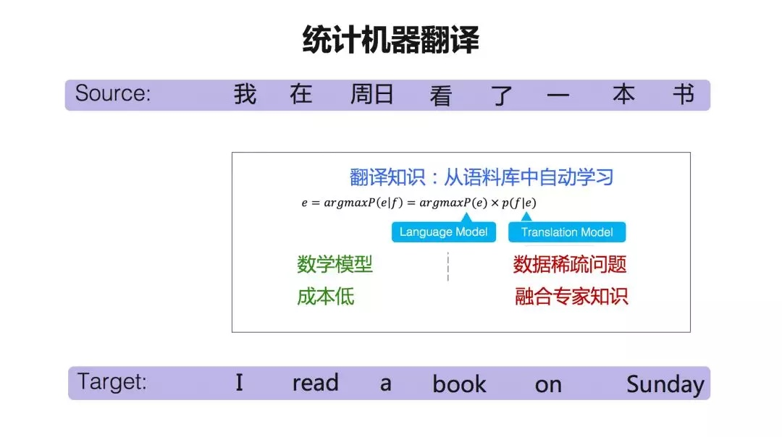
Translating knowledge mainly comes from two types of training data: parallel corpus, one sentence of Chinese and one English sentence, and this sentence of Chinese and English corresponds to each other, also called bilingual corpus; monolingual corpus, for example, English only is called the monolingual corpus.
What can be get from the parallel corpus? The translation model can provide a table similar to a dictionary, which is generally called a "phrase table". For example, "在周日" can be translated into "on Sunday". There is also a probability, which measures the likelihood of two words or phrases corresponding to each other. In this way, the "phrase list" establishes a bridge relationship between the two languages.
So what can we do with a monolingual corpus? We use a monolingual corpus to train the language model. The language model is to measure whether a sentence is authentic and fluent in the target language. For example, if we say "read a book" here, there is no problem with this expression. The probability of "read a" followed by the word "book" maybe 50 percent, so what about "read a TV"? The possibility is very low. Because this does not conform to the grammar of the target language.
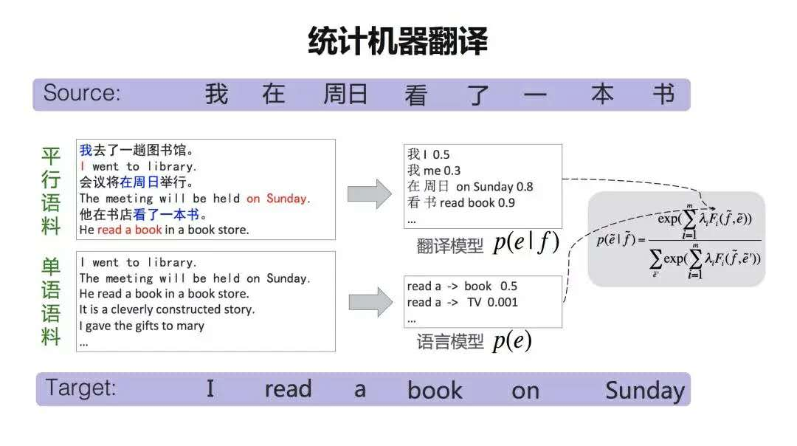
Therefore, the translation model establishes a bridge between the two languages, and the language model measures whether a sentence is fluent and authentic in the target language. The combination of these two models forms a formula such as statistical machine translation.

3.3. Neural Machine Translation
Neural machine translation has risen rapidly in recent years. Compared with statistical machine translation, neural machine translation is relatively simple in terms of the model. It mainly contains two parts, one is the encoder and the other is the decoder. The encoder expresses the source language into a high-dimensional vector after a series of neural network transformations. The decoder is responsible for re-decoding (translating) this high-dimensional vector into the target language.
With the development of deep learning technology, neural machine translation began to rise in 2014. In 2015, Baidu released the world's first Internet neural network translation system. After just 3 or 4 years, the neural network translation system has surpassed statistical methods in most languages.
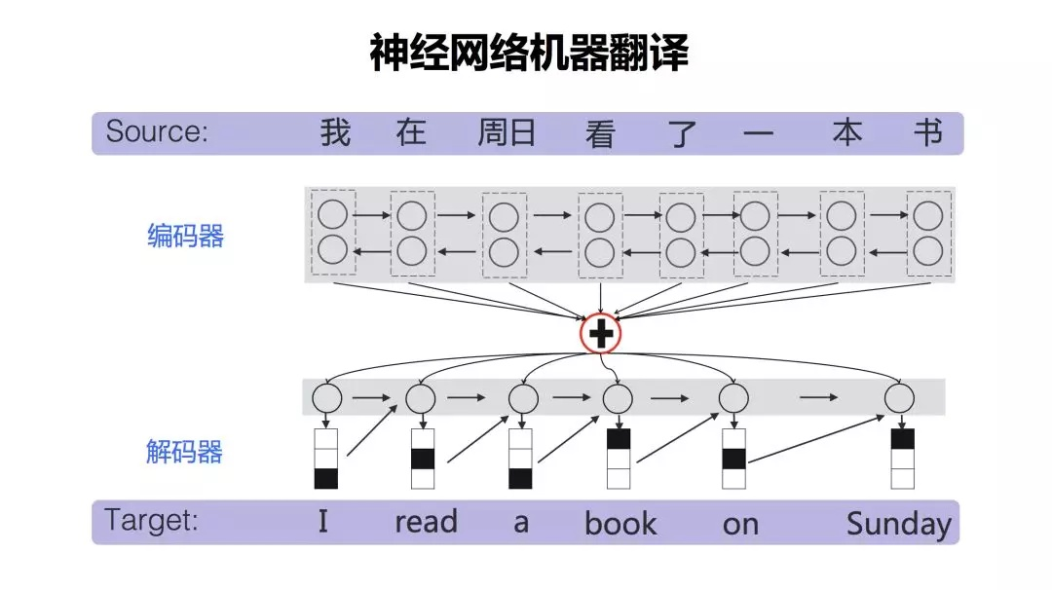

References

[1] National Research Council. Automatic Language Processing Advisory Committee. "Language and machines; computers in translation and linguistics; a report." Methods in Molecular Biology 260 (1966): 73-82.
[2] Wolfram Wilss. The Science of Translation: Problems and Methods. 上海外语教育出版社, 2001.
[3]黎亚飞, and 张瑞华. "机器翻译发展与现状." 中国轻工教育 5(2019).
[4]许钧, and 穆雷. 翻译学概论. 译林出版社, 2009..
[5]https://www.zhihu.com/answer/635030291
[6]https://zhuanlan.zhihu.com/p/223033781

